A. NATURE OF THE AWARD

Awarding Institution: Kingston University

Programme Accredited by: British Computer Society

Final Award(s): Foundation Degree in Science

Intermediate Award(s): N/A

Field Titles: IT for E-Business
IT for E-Business (Network Specialist)
IT for E-Business (Software Specialist)
IT for E-Business (Web Specialist)
IT for E-Business (Business Applications)

FHEQ Level: Intermediate

Credit rating by level: 120 @ level 1, 120 @ level 2

JACs code: G400, G500, G600

QAA Benchmark Statement(s): Computing

Minimum Registration: 2 years

Maximum Registration: 4 years

Date Specification Produced: March 2003

Date Specification Revised: August 2011

Faculty: Science, Engineering and Computing

School: N/A

Location: Carshalton College
Kingston College
Merton College
Richmond Adult Community College
Richmond-upon-Thames College
South Thames College
West Thames College
Kingston University

B. FEATURES OF THE FIELD

The suite of Foundation Degrees in IT for E-Business is run by the New Technology Institute at Kingston University in partnership with local colleges of Further Education. Current FE college partners are as follows:

Carshalton College  Kingston College  Merton College  Richmond Adult Community College | Richmond-upon-Thames College  South Thames College  West Thames College.
The foundation degree programme is validated and awarded by Kingston University with courses at the FE colleges run as a franchise under license from Kingston University.

As with all Foundation Degrees, this programme is a mixture of Taught Elements and Work Based Learning. The whole programme is designed to run over 2 years, but may be completed over a longer period to suit an individual’s or company’s requirements. It offers a framework providing individuals working in the IT Services sector with a training programme that will increase their knowledge and vocational skills. In addition it will ensure that local companies, including SMEs, have the opportunity to develop their employees to become more effective members of the workforce.
The IT for E-Business foundation degree programme is offered in a generic form plus four specialist forms to enable students to develop a particular area of expertise within the area of IT for E-Business.

- Titles:

The titles of the fields within the E-Business foundation degree programme are:
- IT for E-Business
- IT for E-Business (Network Specialist)
- IT for E-Business (Software Specialist)
- IT for E-Business (Web Specialist)
- IT for E-Business (Business Applications)

2. Features:

The Fields have the following major features:

- A high proportion of work-related learning which allows students to continue in full-time employment whilst studying for the foundation degree.
- The content for appropriate vendor certification is covered as part of each award enabling students to sit for the relevant vendor certification, eg.Microsoft MCSA, Cisco CCNA, Oracle DBA certificate
- A common learning management system to facilitate quality assurance across various partner colleges and support work-based learning
- The opportunity to top-up to full honours degree within a further 15 months of full-time study.
- Part-time study, if students cannot commit to the full-time study route for the foundation degree.

In addition, graduates of a foundation degree are provided with opportunities to participate in lifelong learning by incorporating a systematic approach to the Accreditation of Prior Learning.

Students are able to participate in Higher Education even though they may not have formal qualifications.

Work-related Learning:

It is expected that students will complete the majority of the foundation degree whilst in full-time employment.

However, students who are in between jobs/contracts or who have been unable to secure employment can be accommodated. In this case work-related learning will be attained through case studies, work placement or through voluntary work.

When students are in employment they are expected to apply their knowledge in the workplace as it is acquired and the foundation degree tutoring system will support students and employers in this process.

3. Modes of Delivery

The field is offered on a full-time or on a part-time basis

Full-time:

- Full-time study requires 7 or more modules to be studied per year, contributing to between 105 and 135 credit points

Part-time:

- Part-time study requires 6 or less modules to be studied per year, contributing to less than 105 credit points

C. EDUCATIONAL AIMS OF THE FIELD

The overall aim of the programme is to produce highly trained graduates in IT for E-Business in order to support the development of the Information Society.

It is the aim of all of the fields to ensure that students of IT for E-Business are employed in industry and commerce in the future:

- have the appropriate combination of technical skills, academic knowledge and business skills to work effectively

- are aware of the actual and potential range of information and computer-based systems and of the ways in which these interact with their material, human, organisational and social environments

- possess the appropriate ability and are equipped to undertake honours degree advanced studies and/or research and development in the computing and information systems disciplines

- can apply their knowledge and skills in the various contexts in which information and computer-based systems are developed. In particular, can both initiate and sustain a planned and disciplined personal effort when working alone and can participate effectively as a member of a team.

SPECIFIC AIMS OF INDIVIDUAL FIELDS

- IT for E-Business

Students will gain a broad understanding of IT for E-Business including Networks, Software and Web technologies, and the application of these technologies to business problems.

- IT for E-Business (Network Specialist)
Students will gain the necessary understanding and skills to design, implement and support a network, including network protocols, LANs, WANs, hardware, software and security.

- IT for E-Business (Software Specialist)
Students will gain the necessary understanding and skills to design, evaluate, develop and implement application software, including be-spoke and packaged software that supports an e-commerce environment.

- IT for E-Business (Web Specialist)
Students will gain the necessary understanding and skills to design, implement and manage websites. A website will be developed that will either support the e-commerce needs of the business that students are working in or the e-commerce needs of an industry case study.
- IT for E-Business (Business Applications)
Students will gain the necessary understanding and skills to identify, develop, plan and apply e-commerce technologies to typical business situations, and which could be applied in the context of their workplace.

D. LEARNING OUTCOMES (OBJECTIVES) OF THE SUITE OF FIELDS

1. Knowledge and Understanding

On completion of any chosen Field all students will be able to do the following:

- describe and apply systems analysis and design methodologies to the design of e-business projects

- demonstrate a sound understanding and usage of computer system components, architectures, operating systems and databases

- describe the fundamental elements and functions of programming languages, explaining the terminology used and providing a framework for comparing the languages

- explain the structure and components of a project planning methodology and apply the methodology to e-business projects

- apply this knowledge and understanding to projects and case studies and in the process solve typical business problems through the application of IT for E-Business.

On completion of each of the following chosen Fields students will have a sound knowledge and understanding of the field and will be able to:

IT for E-Business

- explain the basic network standards and how they relate to the operation of a network, including LANs and WANs (further developed in Network Specialist Field)

- identify the basic management and security issues both from within a company and using external links such as E-mail and Internet (further developed in Network Specialist Field).

- describe the principles of setting-up and managing a website (further developed in Web Specialist Field)

- outline how e-commerce can benefit an organisation and describe common applications and their relative value in business terms (further developed in Business Applications Field)

- give examples of multi-media applications and describe the future potential of multi-media systems for e-business (further developed in Web Specialist Field)

- illustrate the principles of information systems management demonstrating a sound understanding of information systems life cycles (further developed in Business Applications Field)

- demonstrate a basic understanding of the marketing opportunities and legal issues associated with the design and implementation of web sites (further developed in Web Specialist and Business Applications Fields)

- apply methodologies to capture business rules and constraints and develop application software and databases

- demonstrate the principles of database design, creation, management and maintenance

IT for E-Business (Network Specialist)

- explain the basic network standards and how they relate to the operation of a network

- explain and demonstrate how networks are interconnected and how the components of the interconnection function and provide services to the networks

- illustrate how network, server and desktop operating systems are used and what their impact is on resources and productivity

- differentiate between the basic network management and security issues both from within a company and using external links such as E-mail and Internet.

- describe the factors limiting network performance and propose design strategies to ensure optimal performance of a network

- illustrate the principles of the Internet, web sites and their designs including the management of web servers and sites, including tuning and performance aspects.

- apply this knowledge to design and implement an E-Business network

- outline the basic principles of project management and how these principles can be related to the work environment.

IT for E-Business (Software Specialist)

- describe how networks are interconnected and how the components of the interconnection function and provide services to the networks

- describe and rigorously apply software design methodologies to the design of e-business software applications and explain the advantages of using CASE tools

- distinguish between the principle programming languages used to develop e-business software applications. Design software solutions using manual and CASE methods.

- apply the principles of designing a good human-computer interface, applying these principles to a system design project

- describe and explain the functions and features of commonly used desktop and publishing software. Apply this software to a range of business problems

- describe and distinguish between the software and database packages most commonly used to implement e-business solutions, including e-mail, financial transaction and billing software

- learn to evaluate and select the “right” software package for a specific business application

- capture business rules and constraints to enable development of applications software and databases

- describe the principles of database design, creation, management and maintenance

IT for E-Business (Web Specialist)

- describe how to set-up and manage a website, applying that knowledge in a practical way

- describe and compare commonly used web technologies, giving examples of web portals, browser technologies and search engines and illustrate how they work

- explain content design, content management, indexing and linking and apply these principles to the design of a web-based information system

- apply the principles of designing a good human-computer interface, applying these principles to a system design project

- describe how to evaluate and select publishing software and implement an information dissemination system

- compare and contrast examples of multi-media applications and explain the nature of the technical and managerial demands of multi-media systems on computer networks

- demonstrate a sound understanding of the marketing opportunities and legal issues associated with the design and implementation of web sites

- capture business rules and constraints to enable development of application software and databases

- describe the principles of database design, creation, management and maintenance

- outline the concepts of relational and object relational databases

IT for E-Business (Business Applications)

- describe the most common business processes and data transactions and illustrate how e-business systems can be applied effectively within an organisation

- outline the principles of the supply chain and explain how B to B and B to C technologies can be applied in this context

- compare the merits of an enterprise-wide approach to e-business software applications and explain the principles of web portals

- describe common e-business software applications and justify how financial and business processes improvements can be achieved through their implementation

- illustrate and apply the principles of information systems management demonstrating a comprehensive knowledge of information systems life cycles

- apply the principles of designing a good human-computer interface, applying these principles to a system design project

- capture business rules and constraints to enable development of applications software and databases

- describe the principles of database design, creation, management and maintenance

2. Cognitive (thinking) Skills

On completion of any one of the fields students will be able to:

- critically analyse and evaluate their own abilities

- assess their own personal development requirements, including setting personal goals, professional goals and developing a personal development plan

- solve complex problems

- plan, conduct and report on an individual project

- assemble data from a variety of sources and discern and establish connections

3. Practical Skills

On completion of all fields students will:

- demonstrate their practical skills and apply them to typical business and technical problems

- have the opportunity to pass a suitable vendor qualification(s) which demonstrates the student’s practical abilities to professional working standards

On completion of each of the following fields students will be able to:

IT for E-Business
- select and use e-business technologies in common business situations

IT for E-Business (Network Specialist)
- design and implement a secure and reliable network design using best practices and design standards

IT for E-Business (Software Specialist)
- analyse a set of business requirements, specify system function requirements and design and write software solutions, selecting suitable package software as required

IT for E-Business (Web Specialist)
- design, evaluate, configure, implement and support web sites using commonly available technologies

IT for E-Business (Business Applications)
- analyse a business case study documenting the processes and data flows and establish where e-commerce solutions could be applied in order to improve business efficiency, OR
- describe an approach to the application of IT for E-Business that addresses the overall needs of a business and identify the options and projects required in order to implement that approach.

4. Key Skills

Key Skills will be an essential component of the programme. They encourage all-round performance and enable qualified students to move easily across different types of job roles. IT Services employers have identified Communication, Problem Solving and Working with Others as priority skills. Consequently these are included as mandatory components of the Foundation Degree in IT for E-Business. Students will be expected to demonstrate competence in the Key Skills with evidence collated, for example in a portfolio, from work-related activities.

The following types of task are planned in order to develop these skills:

a. Self Awareness:
- reflect on his/her own academic and personal development
- design a personal development plan
- research into a given subject and plan future lines of enquiry

b. Communication Skills:
- make effective contributions to group work and discussions
- make oral presentation on a complex topic
- select and extract material from primary and secondary sources
- read and collate material from written and spoken sources
- provide written materials in a variety of formats fit for purpose
- incorporate images in documents including titles, data, graphics and diagrams

c. Interpersonal skills
- review and evaluate progress of groups and collective performance
- identify ways of improving the performance of groups and own contribution to groups
- enable a high level of communication, team working and inter personal skills that will ensure that they are able to operate effectively at work

d. Creativity and Problem Solving:
- collect data from primary and secondary sources selectively
- evaluate and present data in suitable formats
- select and use appropriate methods to manipulate primary and secondary data
- produce a complex document combining information from a variety of sources

e. Research and information literacy skills
- search for, retrieve and store information from IT sources
- select appropriate on-line information and evaluate its quality
- use on-line communication systems to send and obtain information including the University’s learning management system
- research into a given subject and plan future lines of enquiry
- use appropriate IT to present text, data and images

f. Numeracy
- record data in appropriate formats
- collect data from primary and secondary data sources selectively
- evaluate and present data in suitable formats for the task in hand
- understand the issues of selection, accuracy and uncertainty in the collection and analysis of data

g. Management and leadership skills
- make effective contributions to group work and discussions
- review and evaluate progress of groups and collective performance
- enable a high level of communication, team working and inter personal skills that will ensure that they are able to operate effectively at work

E. FIELD STRUCTURE

The suite of fields is part of the University’s Undergraduate Modular Scheme (UMS). Fields are made up of modules which are offered at five levels, Levels 0, 1, 2, 3 and M. Levels are progressively more challenging as a student progresses through a field. A foundation degree consists of 270 credits, 120 at Level 1, 120 at Level 2 and 30 credits at Level 3.

The learning outcomes for the modules are delivered through a combination of college based and work-based activity. The work-based element of modules will normally be achieved through the students’ employment. Where students are not employed these outcomes will be delivered through work-related activity designed by the colleges. In the table below core, option, pre and co-requisites can be identified for each of the Fields. This table is then followed by a series of diagrams that outline the structure of each Field.

Table 4.1 overleaf summarises the modules used by the FD Fields in IT for E-Business at Levels 1, 2 and 3.

Module Code | Module Name | Co-requisites | Pre-requisites | IT fro E-Business | IT for E-Business  Networking Specialist | IT for E-Business  Web Specialist | IT for E-Business  Multimedia

LEVEL 1
CI1621 | Professional Skills |  |  | Core | Core | Core | Core
CI1603 | Routing Protocols & Concepts | CI1601 |  | Option | Core
CI1610 | Introduction to Programming |  |  | Core | Core | Core | Core
CI1601 | Networking Fundamentals | CI1603 |  | Option | Core
CI1630 | Systems Analysis and Design 1 |  |  | Core | Core | Core | Core
CI1612 | Network Software |  |  | Option | Core
CI1622 | IT Tool Box |  |  | Core | Core | Core | Core
 |  |  |  | Option
CI1615 | Website Management |  |  | Option |  | Core | Core
CI1616 | Introduction to Multimedia Production |  |  | Option |  | Core | Core
CI1617 | Introduction to Website Development |  |  | Option |  | Core | Core
CI1620 | Project Level 1 |  |  | Core | Core | Core | Core

Table 4.1

Module Code | Module Name | Co-requisites | Pre-requisites | IT for E-Business | IT for E-Business  Networking Specialist | IT for E-Business  Web Specialist | IT for E-Business  Multimedia
LEVEL 2
CI2624 | Information and Project Management |  |  | Core | Core | Core | Core
CI2625 | Understanding Information |  |  | Option |  | Core | Core
CI2604 | Accessing the WAN | CI2612 | CI1630 | Option | Core
CI2603 | Network Environment Management |  | CI1612 | Option | Core
CI2612 | LAN Switching & Wireless | CI2604 |  | Option | Core
CI2610 | Business System Analysis 2 |  | CI1630 | Core | Core | Core | Core
CI2611 | Data Server Technology |  |  | Core | Core | Core | Core
CI2614 | Project Level 2 |  |  | Core | Core | Core | Core
CI2616 | Advanced Website Development and Production |  | CI1615 and (CI1616 or CI1617) | Option |  | Core
CI2622 | E-Commerce Applications |  |  | Option |  | Core
CI2615 | Computer Systems Network Security |  |  | Option | Core
CI2607 | Intro to Computer Games
Ci2608 | Multimedia Design
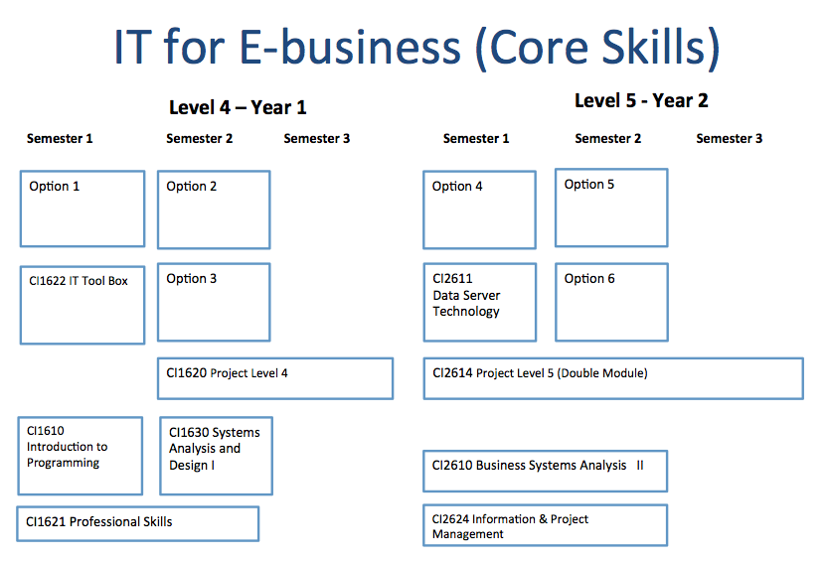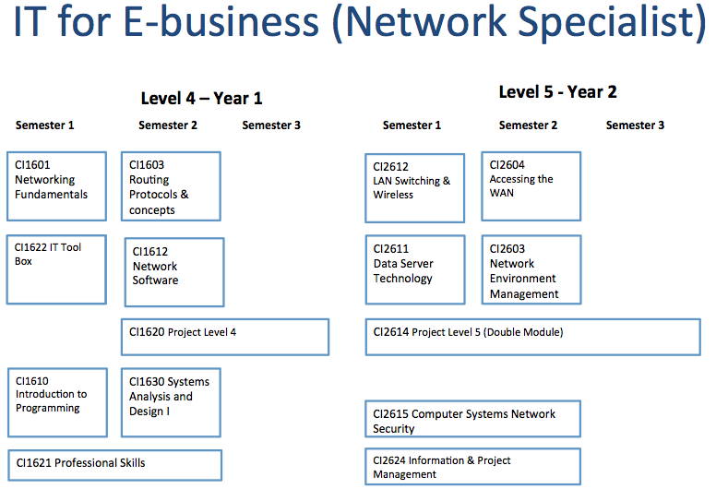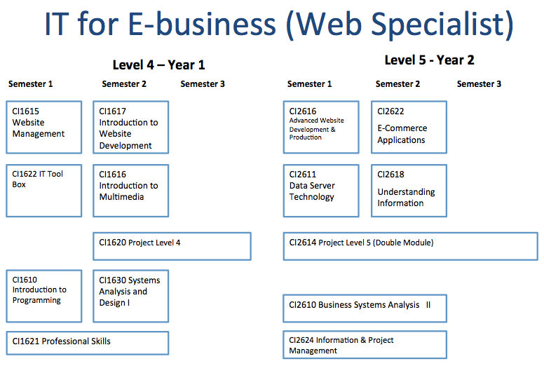
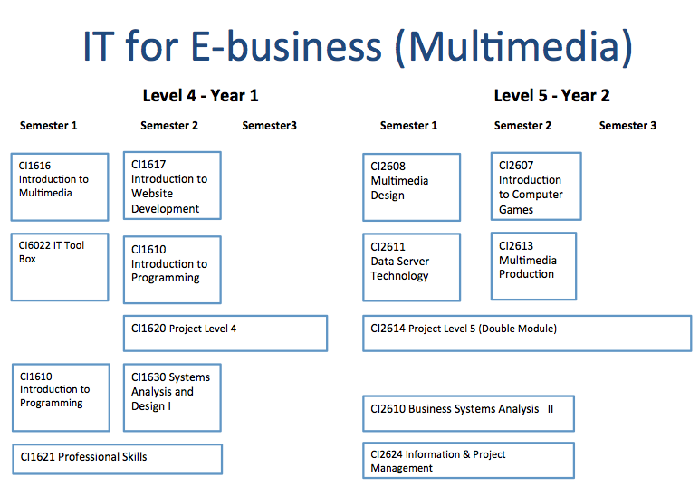

F. FIELD REFERENCE POINTS

- The suite of fields take into account the honours degree subject benchmark statement for Computing
- The suite of fields meet the draft QAA benchmark statement for Foundation Degrees
- All procedures associated with the suite of fields comply with the QAA Codes of Practice for Higher Education and the National Qualifications Framework
- Vendor specific requirements

G. TEACHING AND LEARNING STRATEGIES

It is recognised that there will be a variety of prospective students applying to undertake these courses including those employed (full-time or part-time), self-employed (full-time or part-time), those seeking work and those wishing just to study. Also, there is bound to be some diversity in the nature of students’ employment.

A significant number of students could be self-employed IT contractors who experience irregular work patterns. Some students may experience redundancy or several changes of employment during their studies, and maternity leave should also be catered for.

It is expected that the majority of students that register will be post school leaving age, i.e. mature students. Consequently the teaching and learning strategies must be flexible in order to cope with this. Therefore the Course Team will be fully committed to the importance of achieving the course aims through the use of a range of different learning methods, attendance modes and resource provision.

Central features of the teaching and learning strategy are:

- the recognition of the importance of work-related learning
- the development of business related skills and Key Skills within a vocational context
- an emphasis on student-centred learning
- the use of a learning management system

Students learning will be supported by lectures, seminars, tutorials, the project/assignment programme, laboratory activities, presentations, individual support at the workplace and accessing ‘on-line’ materials.

- Lectures will be used to introduce new concepts and ideas and to provide students with essential information and underpinning knowledge. The seminars and tutorials will be module specific and will be used by the module tutors to monitor student progress, provide additional support and guidance and to encourage student participation.
- The projects and assignments will be used to assess student progress, make judgements on the achievement of outcomes and to establish links between modules and ensure overall coherence of the field.
- Laboratory activities will be used to develop the students’ ability to apply knowledge and acquire design and problem solving skills.
- An essential feature of the Foundation Degree is the opportunity students have of learning at work. Regular contact will take place with the supervising institution.
- Individual and group presentations, using audio-visual aids, will be a key strategy in the development of communication skills.
- Materials produced by specific vendors will be used to provide students with essential knowledge and skills associated with the relevant vendor certification.

Work-related Learning:
This suite of Foundation Degrees has been designed with the understanding that employees learn through experience of work. There is significant evidence that individuals acquire skills and knowledge through the activities that they are required to engage in while at work. This learning has traditionally been supported by work place supervisors and managers.

Each Foundation Degree will provide employees working in the IT sector with the opportunity of formal accreditation of this learning by putting in place a framework of learning outcomes and an assessment methodology.

Learning in the workplace will take place in the context of a course that involves a large proportion of face-to-face college study, a variety of communication media and a virtual learning environment. The colleges will therefore ensure that sufficient “signposting” and support for work-based learning will be provided.

Assessment of work-based learning will be based on the following principles (following SEEC’s guidelines):
- work-based learning does not require the student to be in full time employment
- the diverse range of students’ a-priori skills and knowledge will be considered at registration and factored into the students’ overall learning programmes
- the outcomes of all relevant work-related learning, past, present and future, will be set in the overall framework of aims, outcomes, levels and standards for the Field studied,
- a programme of learning will be developed in conjunction with employers and/or Institutions
- students will be supported by their college whilst in their place of work.
- there will be regular contact with supervising Institutions and employers
- progress will be reviewed at regular intervals
- work-related learning will be documented, for example in student Log Books, to enable it to be assessed against standards set out in the overall assessment frameworks

Flexible Provision:
In order to provide students and employers with a practical and manageable vocational study programme, the IT for E-Business courses are flexible in the following ways:

Attendance modes
Whenever possible modules will be offered in a variety of modes across the partner institutions (daytime, evening, weekend and block). Any student will typically study for a maximum of 4 modules in any semester or 6 month period. Of these 4 modules 2 will normally be work-related.

Online support
Access to resources and communication facilities will be available through the Learning Management System Blackboard. This will allow support to be given by tutors and other students when off campus, at home or in the workplace. Access to library catalogues, recommended websites and e-books will be facilitated through Blackboard.

Work-related learning
If a student is employed in work relevant to their field they will be able to structure much of their learning in this context. However, if they are not in work they will be able to use case study material, carry out voluntary work and/or focus on projects within the institutions in which they are studying in order to achieve the learning outcomes of their modules. Additionally Blackboard will provide communication facilities and resources that can be accessed through a web browser at work.

Resources
Students will have access to their local institution’s Learning Resources, their NTI lab and the facilities of Kingston University (Learning Resource Centres and computing facilities). This will give them access to a broad range of books and computing facilities and a variety of locations to visit.

H. ASSESSMENT STRATEGIES

Map of field learning outcomes to modules.

Level 4 Modules  Field learning outcomes | CI1621 | CI1603 | CI1610 | CI1601 | CI1630 | CI1612 | CI1622 | CI1615 | CI1616 | CI1617 | CI1620
Knowledge and Understanding
 | F | F | F | F | F | F | F | F | F | F | F
 | S | S | S | S | S | S | S | S | S | S | S
Cognitive (thinking) Skills
 | F | F | F | F | F | F | F | F | F | F | F
 | S | S | S | S | S | S | S | S | S | S | S
Practical Skills
 | F | F | F | F | F | F | F | F | F | F | F
 | S | S | S | S | S | S | S | S | S | S | S
Key Skills
Self awareness skills
 | F | F | F | F | F | F | F | F | F | F | F
 | S | S | S | S | S | S | S | S | S | S | S
Communication skills
 | F | F | F | F | F | F | F | F | F | F | F
 | S | S | S | S | S | S | S | S | S | S | S
Interpersonal skills
 | F | F | F | F | F | F | F | F | F | F | F
 | S | S | S | S | S | S | S | S | S | S | S
Creativity and problem solving
 | F | F | F | F | F | F | F | F | F | F | F
 | S | S | S | S | S | S | S | S | S | S | S
Research and information literacy skills
 | F | F | F | F | F | F | F | F | F | F | F
 | S | S | S | S | S | S | S | S | S | S | S
Numeracy
 |  | F |  | F | F | F | F |  |  |  | F
 |  | S |  | S | S | S | S |  |  |  | S
Management and leadership skills
 | F |  |  |  | F |  | F |  |  |  | F
 | S |  |  |  | S |  | S |  |  |  | S

Level 5 Modules  Field learning outcomes | CI2624 | CI2625 | CI2604 | CI2603 | CI2612 | CI2610 | CI2611 | CI2614 | CI2616 | CI2622 | CI2615 | CI2607 | CI2608
Knowledge and Understanding
 | F | F | F | F | F | F | F | F | F | F | F | F | F
 | S | S | S | S | S | S | S | S | S | S | S | S | S
Cognitive (thinking) Skills
 | F | F | F | F | F | F | F | F | F | F | F | F | F
 | S | S | S | S | S | S | S | S | S | S | S | S | S
Practical Skills
 | F | F | F | F | F | F | F | F | F | F | F | F | F
 | S | S | S | S | S | S | S | S | S | S | S | S | S
Key Skills
Self awareness skills
 | F | F | F | F | F | F | F | F | F | F | F | F | F
 | S | S | S | S | S | S | S | S | S | S | S | S | S
Communication skills
 | F | F | F | F | F | F | F | F | F | F | F | F | F
 | S | S | S | S | S | S | S | S | S | S | S | S | S
Interpersonal skills
 | F | F | F | F | F | F | F | F | F | F | F | F | F
 | S | S | S | S | S | S | S | S | S | S | S | S | S
Creativity and problem solving
 | F | F | F | F | F | F | F | F | F | F | F | F | F
 | S | S | S | S | S | S | S | S | S | S | S | S | S
Research and information literacy skills
 | F | F | F | F | F | F | F | F | F | F | F | F | F
 | S | S | S | S | S | S | S | S | S | S | S | S | S
Numeracy
 | F | F | F | F | F | F | F | F |  |  |  | F
 | S | S | S | S | S | S | S | S |  |  |  | S
Management and leadership skills
 | F |  |  |  |  |  |  | F
 | S |  |  |  |  |  |  | S

I. ENTRY QUALIFICATIONS

1. The minimum entry qualifications for the field are:
Entry is intended for mature students with work experience. Any formal qualifications and or relevant experience equivalent to five GCSE and GCE passes including two six-unit awards (for example, two A2 awards or a Vocational A Level double award, or two A Levels) will be considered. Vendor qualifications will be considered for exemptions and course entry; or
International Baccalaureate passed at a suitable level; or
Other overseas qualifications of equivalent standard to the above. The offer of a place is dependent on achieving an English Language qualification as well as an academic qualification

2. Typical entry qualifications set for entrants to the field are:
A total of 140 points at AS and A2 from three subjects or equivalent performance in other NQF Level 3 qualifications.

J. CAREER OPPORTUNITIES

Students studying these fields may or may not currently be in employment.

The foundation degree enables them to gain credit for:

- what they already know and are doing in the work place and,
- for vocational training undertaken in order to satisfy short-term work-related needs, eg. CISCO, Microsoft certification

Additionally, the foundation degree provides students with a formal academic framework for their current work that enables them to study e-Commerce as a broad and professional discipline. Successful students can then gain appropriate academic and professional qualifications.

All these features improve the career prospects of the individuals both within their current employment and in the job market.

The foundation degree also equips the student with knowledge and skills that can be readily applied to the benefit of an employer.

The benefits to employers are that:

- vocational training can be provided in order to meet companies’ short-term needs
- up-to-date technical knowledge and understanding can be applied immediately
- a career enhancing education can then be offered to motivate and develop selected employees.

K. INDICATORS OF QUALITY

1. Established research culture:
Kingston University’s research programmes have been recognized as nationally and internationally competitive in the last Research Assessment Exercise (RAE), and its originality and importance is reflected in greatly increased support from government, industry and charities.

Current research includes Computer Vision and Digital Imaging, Applied Information Systems, Data Communications and Networking, Software Engineering, Information Management, Complex Intelligent Systems and New Media Design.

2. Leading use of Learning Technology:
Innovative technologies are adopted throughout the University and CIS currently have two main streams of research - the design of collaborative learning systems, and telematics for education and culture.

The NTI have adopted Blackboard (the Learning Management System) across all of its foundation degree programmes .

3. Long experience of running sandwich degrees:
Kingston University established a considerable reputation for running high quality and effective Engineering and Science sandwich course degrees in the 1960s.

Students on these degrees have been sponsored by many blue-chip organizations such as GEC, British Aerospace, ICL, Health Authorities and public Utlilities.

4. BCS accredited under graduate courses.
The University has a long and notable track record of running BCS accredited courses again to significant organizations such as the Home Office and H M Treasury.

5. Quality Audit:
The University has received excellent Quality Audit reports from the QAA Institutional Audit process.

The partner colleges have an excellent record for the delivery of courses at National Qualifications Level (NQF) Levels 2 and 3 with considerable experience at Level 4 in the delivery of HND and HNC programmes.

L. APPROVED VARIANTS FROM THE UMS/PCF

None

M. POTENTIAL TOP-UP REQUIREMENTS TO AN HONOURS DEGREE

A foundation degree in IT for E-Business will be awarded when the following conditions have been met:

- At least 8 Level 1 modules have been completed and 120 credit points attained
- At least 8 Level 2 modules have been completed and 120 credit points attained

On completion of one of the IT for E-Business foundation degree Fields students have the opportunity to top up to a BSc Honours degree in Computer Science or in Information Systems Design. They may have to study additional appropriate level 2 modules in order to acquire the required knowledge. This will normally require studying and completing a minimum of 2 further level 2 modules (30 level 2 credits) and 8 further level 3 modules (120 level 3 credits) to suit the requirements of their chosen Field at Honours level.

Advice and guidance on these top-up requirements will be provided by course tutors.

