Template C4



Programme Specification

Title of Course: Graduate Diploma Residential Work (Children’s)

Date first produced | 30/10/2024
Date last revised | 07/04/2026
Status | Live
Date of implementation of current version | 01/09/2025
Version number | 5
Faculty | Faculty of Health, Science, Social Care & Education
Cross-disciplinary
School | School of Education, Midwifery and Social Work
Department | Department of Social Work and Social Care
Delivery Institution

This Programme Specification is designed for prospective students, current students, academic staff and employers. It provides a concise summary of the main features of the programme and the intended learning outcomes that a typical student might reasonably be expected to achieve and demonstrate if they take full advantage of the learning opportunities that are provided. More detailed information on the learning outcomes and content of each modules can be found in the course VLE site and in individual Module Descriptors.

SECTION 1: GENERAL INFORMATION

Award(s) and Title(s): | Graduate Diploma Residential Work (Children’s)
Exit Award(s) and Title(s):
Course Code
For each pathway and mode of delivery
UCAS code  For each pathway | No UCAS code required

Awarding Institution: | Kingston University
Teaching Institution:

Location: | Kingston Hill
Language of Delivery: | English
Delivery mode: | Category 3: Blended predominantly online (41-99% of scheduled L&T hours delivered online)
Learning mode(s): | Distance Learning
Minimum period of registration: | Distance Learning - 18 months
Maximum period of registration: | Distance Learning - 3 years
Entry requirements | Kingston University typically uses a range of entry requirements to assess an applicant's suitability for our courses. Most course requirements are based on UCAS Tariff points, usually stipulated as a range, and are sometimes coupled with minimum grades in specific relevant subjects. We may also use interview, portfolio and performance pieces to assess an applicant's suitability for the course. We recognise that every person's journey to Higher Education is different and unique and in some cases we may take into account work experience and other non-standard pathways onto University level study.  Additionally, all non-UK applicants must meet our English language requirements.  Please see our course pages on the Kingston University website for the most up to date entry requirements
Regulated by | The University and its courses are regulated by the Office for Students
Programme Accredited by: | This course is professionally endorsed at Category 2 by the Social Pedagogy Professional Association. This will confer the title 'Level 6 Social Pedagogy Practitioner' to those who successfully complete the course. Completion of the Course confirms Ofqual D 'Occupational Competence and /or Licence to Practice' and D1 'Competence in an occupational role to the standards required'.
Approved Variants: | The following variants from the Academic Framework requirements and the PG regulations (AR3) have been approved and are in place for this course. To access the regulations please click here.  1. This programme is approved as an 18 month, rather than 24 month, Graduate Diploma.  2. There is no Compensation for Academic Failure permitted on the first module (The Big Picture), nor on the module to qualify as a Registered Manager of a children’s home (The Head of the Household).  3. Permit to allow option modules
Is this Higher or Degree Apprenticeship course? | No

SECTION 2: THE COURSE

- Aims of the Course

Residential Care work is one of the most important jobs for looking after society’s most vulnerable young people. This Graduate Diploma is aimed at those working in Children’s Homes and similar settings, whether you’re new to the work or already experienced. It gives you a qualification at Level 6 and the professional title ‘Social Pedagogy Practitioner’; it is endorsed by the Social Pedagogy Professional Association. This course is employment based - you study while you’re working, bringing your work experience into your learning, and your course learning into your work.
This Graduate Diploma will allow you to work more effectively with young people in care and similar settings using Social Pedagogy confidently. It will significantly increase your skill in using relationship-based approaches, broadening your understanding of the systems both you and the young people you work with need to navigate. You will increase your professional authority and identity, as well as your confidence in asserting your role for positive outcomes. For your final module, you can choose to qualify as a Registered Manager, exploring different leadership approaches and finding your voice as a leader. This Graduate Diploma will enable you to progress your career in this rewarding and vocational field.

The aims of the course are to:

- enable learners to develop and use relevant social pedagogy and social pedagogy aligned skills and knowledge for working with children and young people; including knowledge of relevant theory, research, social policy, regulatory and legislative frameworks, and ethics and values
- enable learners to understand the perspectives, remit and cultures of different professions working with children and young people in Residential Care and similar settings, developing skill and confidence in navigating these systems to advocate for children
- enable learners to develop creative social pedagogy skills and apply theoretical knowledge and research-led best practice for working effectively to support children and young people
- equip learners to explore the dynamics of inter-professional practice in social care work with children in care, and critically consider the contributions of each profession to the lives and outcomes of children
- encourage the development of self-awareness, reflective ability, resilience, autonomy, teamwork and leadership skills within Residential Care and similar settings
- foster the ability to work in accordance with the Social Pedagogy Charter and Standards of Proficiency, centred around an appreciation of the perspectives and voice of children and young people in Residential Care and similar settings
- enable learners to understand and apply the principles of social pedagogy practice and theoretical perspectives relevant to professional work with children and young people, enhancing skill and confidence in practice
- empower leaders within Residential Care to explore leadership theories and approaches and find their style and voice as leaders working to support young people in care and effectively lead a home and its team towards positive outcomes for children and young people

- Programme Learning Outcomes

The programme learning outcomes are the high-level learning outcomes that will have been achieved by all students receiving this award. They have been aligned to the levels set out in ‘Sector Recognised Standards in England’ (OFS 2022).

Programme Learning Outcomes

 | Knowledge and Understanding  On completion of the course students will be able to: |  | Intellectual Skills  On completion of the course students will be able to |  | Subject Practical Skills  On completion of the course students will be able to
A1 | Use applied knowledge of the history, context and positioning of residential children's homes (and similar settings), and of your own place, role and motivations within that system. | B1 | Demonstrate understanding of how best to work with children and young people who have experienced / are experiencing and re-experiencing trauma, abuse, neglect, exploitation and other harms, with skill and confidence in deploying social pedagogy methods to work therapeutically with them and advocate for them. | C1 | Apply professional knowledge and skilled confidence in navigating the systems, laws, policies and regulatory requirements in residential care and similar work, with an ability to assert your professional role to advocate for young people in care (and similar settings).
A2 | Use applied knowledge of children and young people's development, trauma, contexts and relationships, with self-awareness and reflection of your own and the team's interactions with these. | B2 | Apply self-awareness, awareness of situational context, and reflection skills (including 'reflection-in-action') to best work individually and in a team to help children and young people. | C2 | For those studying the Registered Manager module: demonstrate knowledge, skill and confidence in leadership approaches and managing a Residential Children's Home (or similar setting) and its staff; apply skill and confidence in effectively leading the team towards positive outcomes for the Home and its children, embodying a social pedagogical ethos.

- Future Skills Graduate Attributes

In addition to the programme learning outcomes, the programme of study defined in this programme specification will engage students in developing their Future Skills Graduate Attributes:
- Creative Problem Solving
- Digital Competency
- Enterprise
- Questioning Mindset
- Adaptability
- Empathy
- Collaboration
- Resilience
- Self-Awareness

- Outline Programme Structure

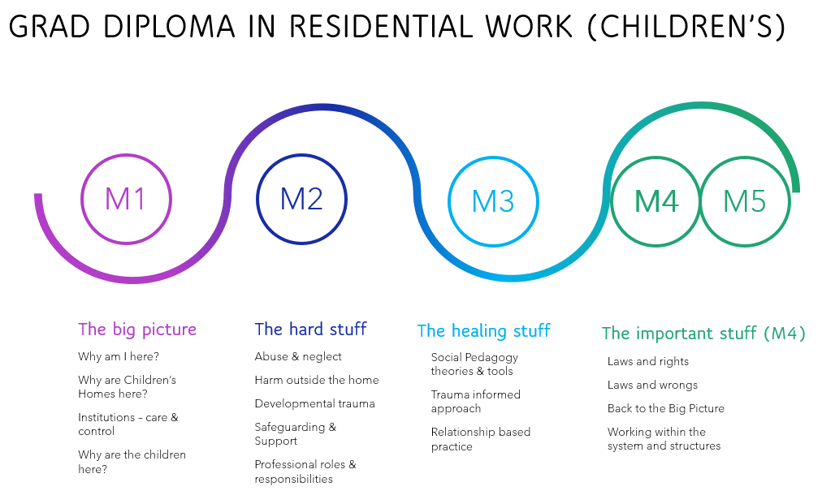
Above indicates the Course Structure, with M4 detailed.
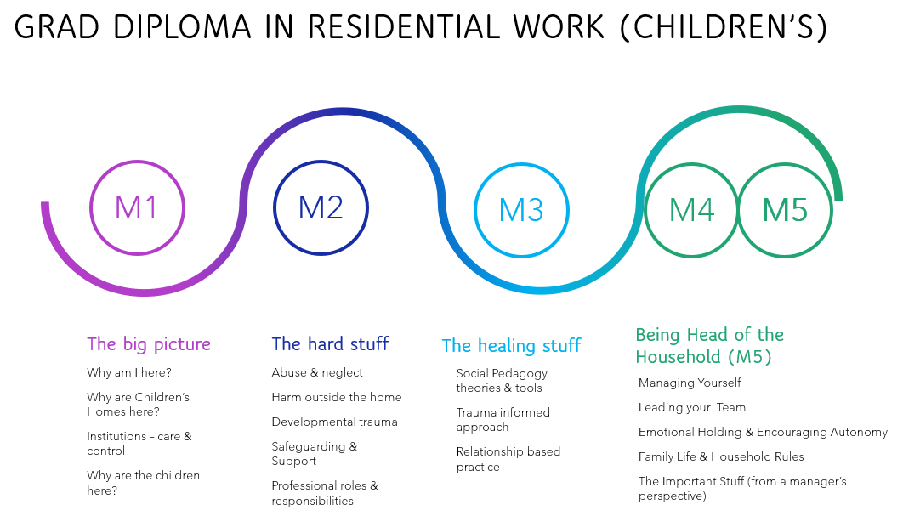
Above indicates the Course Structure with M5 detailed.
Full details of each module will be provided in module descriptors and in the module canvas pages.

Note: As per GR5 within the general regulations, the University aims to ensure that all option modules listed below are delivered. However, for various reasons, such as demand, the availability of option modules may vary from year to year or between teaching blocks. Students will be informed of the availability of option modules through the Online Module Selection process.

This course is aimed at residential care practitioners (with or without UG degrees) who are aspiring to gain a qualification to enhance their knowledge and skill in residential work and advance in their careers within social care. Typically practitioners in Residential Care are only required to have a CACHE L3; this course is a Level 6 Graduate Diploma, which aims to raise the bar for knowledge and skills in residential work with children, young people, and young adults. This is an 18-month Level 6 Graduate Diploma of 120 Credits. Learners take 4 Modules: all learners take Module 1, 2 and 3. Learners can choose between Module 4 or Module 5. Module 5 qualifies learners to be Registered Managers of Children's Homes (in England).

This is a Distance Learning course for those working full (or part) time in employment. The learning and teaching is blended, with both synchronous and asynchronous activities. This means there is a blend of in-person and online learning sessions, with a mix of 'live' teaching (this is known as 'synchronous' and can be either in person or online) and activities that you can do in your own time, when convenient for you (this is known as 'asynchronous').

For some of the learning, sessions are 'hybrid', meaning you can choose to either attend in person or online, at your convenience. The blended nature of this Distance Learning course enables you to bring your experiences from your workplace into your course learning, and vice versa, and allows you the flexibility to study for this Graduate Diploma while still in employment.

The first module studied is called The Big Picture, and is a 6-month Module. The remaining Modules (The Hard Stuff, The Healing Stuff, The Important Stuff, and The Head of the Household) are taught contemporaneously over a 12-month period. Where The Head of the Household module is chosen, due to PSRB requirements for Registered Managers, this module is not eligible for 'Compensation for Academic Failure'.

Following The Big Picture, the Modules are taught contemporaneously to ensure pedagogical coherence and cross-fertilisation of learning between and across Modules: topics, knowledge and skills all 'speak' to one another, and this is similarly reflected in the Assessment Strategy.

The Head of the Household incorporates the topics taught in The Important Stuff but from a Manager's perspective. This ensures the important aspects of laws, rights, regulations, policies, systems and structures are all understood, with a grasp of not only the Home and its Staff's responsibilities in these aspects, but the remit and responsibility of a Registered Manager (for example an RM's role in Inspections of the Home, in addition to understanding the Staff's role and duty in this).

All students will be provided with the University regulations and specific additions that are sometimes required for accreditation by outside bodies (e.g. professional or statutory bodies that confer professional accreditation). Full details of each module will be provided in module descriptors and student module guides on Canvas.

Graduate Diploma Residential Work (Children’s)

Level 6
Graduate Diploma Residential Work (Children’s)
Core modules | Module code | Credit  Value | Level | Teaching Block | Pre-requisites | Full Time | Part Time
The Big Picture | SW6020 | 30 | 6 | Year Long | None | 1
The Hard Stuff | SW6021 | 30 | 6 | Year Long | None
The Healing Stuff | SW6022 | 30 | 6 | Year Long | None
Optional Modules
The Head of the Household | SW6024 | 30 | 6 | Year Long | None
The Important Stuff | SW6023 | 30 | 6 | Year Long | None

Exit Awards at Level 6

The whole Graduate Diploma is taught at Level 6.

- Teaching, Learning and Assessment

During Pre-Induction you will be given an introduction to academic learning at Level 6. In order to ensure all Learners are ready to enter into Level 6 study while working, support sessions are provided by the Course Team, who will ensure you have full access to relevant systems (Canvas, Teams etc.) and are familiar with where and how to utilise course materials, as well as where and how to access support (Personal Tutoring, academic support, and supports for additional learning needs).
This is a Distance Learning course where you are primarily in the workplace. Learning is online, in person, and hybrid (where you can choose to either attend in person or online). Personal Tutors will respond to you flexibly, modelling the responsive and adaptive practice that is required in Residential Care and similar work. This responsive support is a fundamental part of the teaching and learning strategy of this Course, and embodies the relationship-focused ethos of Social Pedagogy.
Assessments are practice-focused, involving demonstration of social pedagogy skill with young people in residential care and similar settings, and practical application of knowledge and critical reflection. For those studying The Head of the Household, assessments focus on the demonstration of leadership skill using social pedagogy.
The curriculum is designed in accordance with Kingston University’s Inclusive Curriculum Framework principles:
· Create an accessible curriculum (conceptually and practically)
· Enable students to see themselves reflected in the curriculum
· Equip students with the skills to positively contribute to and work in a global and diverse environment.

- Support for Students and their Learning

The Course Team and teaching delivery includes diverse staff with both professional and lived experiences relevant to the subject knowledge and skills, and the contribution of Care Experienced people is key to the teaching & learning and assessment. Real World Learning (RWL) is an integral aspect of the Course, since Learners are typically in employment and/or have significant employment experience in Residential Care and/or similar work. Where you are sponsored by your employers to complete the Course, your Line Manager and/or Registered Manager will support your learning. Where you are self-funding, you are encouraged to also involve your Line Manager and/or Registered Manager in supporting your learning on this Course.
Where possible, the Course Team will endeavour to visit each employment setting in order to capture a 3D Scan and/or 360-degree capture, to render a Virtual and/or 360-degree Environment of your workplace, with which simulations for skills practice are then created for you.
Learning will take place in small groups on campus, in your bespoke virtual environment, and online. Online learning includes both synchronous and asynchronous activities. Learners from different settings, e.g. different Children's Homes, will be paired and placed into small working groups for peer-working and critique of practices and norms across different settings, organisations and institutions.
This course has been designed to take account of Kingston University Curriculum Design Principles. Following successful completion of the first module 'The Big Picture', learning is informed and reinforced by learning in the others (Modules 2, 3, 4 or 5).
Course materials and skills simulations are released as cases develop, requiring you to respond to emerging situations as they evolve, and adapt your application of professional knowledge and skill. This variety of learning opportunities enables different learning styles whilst also reflecting the sorts of learning needed for effective social pedagogy practice within residential care (and similar settings).
Preparation for teaching sessions and consolidation afterwards take place generally through e-learning and guided private study, whilst concepts are introduced most often through formal lectures, both synchronously and asynchronously. Knowledge of research methods is fostered incrementally and critical thinking is supported along with debate and the exploration of diverse views. A strong emphasis is placed on equity and inclusion, valuing diversity, and encouraging professional confidence.
The Virtual Learning Environment (Canvas) is used in various ways in all modules, as are Microsoft Teams and Microsoft Spaces, and you will be introduced to new technologies to enhance learning. Virtual and Augmented Reality, Artificial Intelligence, 360-degree experience, and other technologies are used to develop your skills, foster learning communities and personalise the curriculum for meaningful skill and knowledge development.
Emphasis is placed throughout the programme on developing group work skills, written and oral communication and presentation skills, analytic thinking and practice, and independent learning skills.
You can choose between completing The Important Stuff or The Head of the Household: the latter allows you to qualify as a Registered Manager, under The Children's Homes Regulations (2015). This module must be fully passed in order to qualify as a Registered Manager.
Flexibility and choice is built into the programme so that wherever possible your individual interests and learning styles can be reflected in the assessments. Methods include course work and practicals. The assessment regime for each module has been designed to provide formative opportunities that allow you to practice and to receive feed-forward on your performance in preparation for summative assessments.
Additional support is available via the Academic Success Centre or other tailored support as necessary. Employability skills are embedded throughout the course and designed in such a way as to enable you to relate the knowledge and skills you are learning to the reality of practice in the contexts in which you work. Kingston University's Future Skills ('Apply' at Level 6) are fully embedded into the programme.

- Ensuring and Enhancing the Quality of the Course

The University has several methods for evaluating and improving the quality and standards of its provision. These include:
- External examiners
- Annual Monitoring and Enhancement
- Continuous Monitoring of courses through the Kingston Course Enhancement Programme (KCEP)
- Student evaluation including Module Evaluation Questionnaires (MEQs), the National Student Survey (NSS)
- Internal and external moderation of graded assignments
- Continuing evaluation against Social Pedagogy Professional Association Standards of Education and Training and Standards of Proficiency, for Category 2 Endorsement

- External Reference Points

External reference points which have informed the design of the course. These include:
- PSRB standards
- QAA Subject benchmarks
- Apprenticeship standards
- Other subject or industry standards

- Development of Course Learning Outcomes in Modules

This table maps where programme learning outcomes are summatively assessed across the core modules for this course. It provides an aid to academic staff in understanding how individual modules contribute to the course aims, a means to help students monitor their own learning, personal and professional development as the course progresses and a checklist for quality assurance purposes.

Module Code |  | Level 6
 |  | SW6020 | SW6021 | SW6022
Knowledge & Understanding | A1 | S |  | S
Knowledge & Understanding | A2 | S | S | S
Intellectual Skills | B1 |  | S | S
Intellectual Skills | B2 | S | S | S
Practical Skills | C1 |  | S | S
Practical Skills | C2 | S | S | S

Students will be provided with formative assessment opportunities throughout the course to practise and develop their proficiency in the range of assessment methods utilised.

Additional Information

QAPCC12 25/26 Change of intake from September to January.
The January intake is a temporary change for the 2025-26 and 2026-27 academic years only, the course will revert to a September intake from the 2027-28 academic year.
Summary of intakes:
2025-26: January 2026 intake
2026-27: January 2027 intake
2027-28 onwards: September 2027 intake (no more January intakes permitted)

