Template C4



Programme Specification

Title of Course: MSc Technology (Maritime Operations)

Date first produced | 01/03/2012
Date last revised | 01/11/2016
Status | Live
Date of implementation of current version | 01/01/2021
Version number | 4
Faculty | Faculty of Engineering, Computing and the Environment
School | School of Engineering
Department | Department of Aerospace and Aircraft Engineering
Delivery Institution | N/A

This Programme Specification is designed for prospective students, current students, academic staff and employers. It provides a concise summary of the main features of the programme and the intended learning outcomes that a typical student might reasonably be expected to achieve and demonstrate if they take full advantage of the learning opportunities that are provided. More detailed information on the learning outcomes and content of each modules can be found in the course VLE site and in individual Module Descriptors.

SECTION 1: GENERAL INFORMATION

Award(s) and Title(s):  Up to 10 pathways | MSc Technology (Maritime Operations)
Intermediate Awards(s) and Title(s):  There are 4 Intermediate awards for each pathway | PG Cert / PG Dip - RN variant
Course Code
For each pathway and mode of delivery
UCAS code  For each pathway | N/A

RQF Level for the Final Award:

Awarding Institution: | Kingston University
Teaching Institution: | N/A
Location: | This workbased learning MSc is a supervised, self-directed award and is conducted off Campus.
Language of Delivery: | English
Modes of Delivery: | Part-time
Available as:
Minimum period of registration: | Part-time - 2 years
Maximum period of registration: | Part-time - 4 years
Entry Requirements: | Normally candidates will have successfully completed the one-year PWO course (above water) or the equivalent Warfare Officer courses for submariners.
Programme Accredited by: | The programme is not accredited
QAA Subject Benchmark Statements: | None
Approved Variants: | None
Is this Higher or Degree Apprenticeship course?

For Higher or Degree Apprenticeship proposals only

Higher or Degree Apprenticeship standard:

Recruitment, Selection and Admission process:

End Point Assessment Organisation(s):

SECTION 2: THE COURSE

- Aims of the Course

The main purpose of this course is to offer students, all of whom who are or have already been practising naval officers, a negotiated and personalised programme of study which develops them further towards their full potential as safe, competent, ethical, confident, research-minded and reflective practitioners.
• To enhance students’ abilities in independent study, research, critical thinking and reflective practice, reinforcing an ethos of life-long learning and continuing professional development.
• Facilitate personal and professional development including the transferable, communications and interpersonal skills necessary for managing and developing further a successful, autonomous and independent practice in the naval environment
The aims of the Postgraduate Diploma and the Postgraduate Certificate are the same as those for the MSc except that, since the PG Dip and PG Cert students do not normally undertake either the individual project or the academic paper + reflective summary, they will not have the same opportunity to engage in the in-depth research and problem solving techniques which the Dissertation or academic paper suitable for publication requires.

PG Dip and PG Cert are normally given as exit awards when students fail to complete the course.

NOTE: The vast majority of students enter the award with maximum advanced standing (120 credits) derived from successful completion of either the one-year Principal Warfare Officer courses of the Royal Navy (RN) or Royal Australian Navy (RAN) or the equivalent Warfare Officer courses for submariners, with associated evidence. The final 60 credits can only normally be taken by students who have reached operational performance standard.

- Intended Learning Outcomes

Graduates from this course will have the ability to use the range of skills indicated below to solve a substantial range of problems concerning modern military systems, operations, policy, strategy and tactics, some of a complex nature.
GENERAL LEARNING OUTCOMES
- The ability to develop, monitor and update a plan, to reflect a changing operating environment;
- The ability to monitor and adjust a personal programme of work on an on-going basis, and to learn independently;
- An understanding of different roles within a team, and the ability to exercise leadership;
- The ability to learn new theories, concepts, methods etc. in unfamiliar situations.
- The ability to undertake critical reflection of both their technical and personal performance
SPECIFIC LEARNING OUTCOMES
In respect of the specific learning outcomes, MSc Technology (Maritime Operations) graduates will also be characterised by some or all of the following. The balance will vary according to the specific details of each programme, one third of which is negotiated with the University.

Modern military systems.
- A comprehensive understanding of the technical underpinning for relevant military systems.
- An awareness of developing technologies related to relevant military systems
- An understanding of concepts from a range of areas including some not currently used in military systems.
Operations
• Ability to conduct maritime operations up to & including Task Unit Level across the full spectrum of conflict
• Ability to manage resources in the Operations Room
• A detailed awareness of how the different sources of intelligence contribute to the overall scenario
Policy
• Wide knowledge and comprehensive understanding of the Rules of Engagement and the ability to advise on their application in complex situations.

Strategy
• Extensive knowledge and understanding of strategy and how it may be applied appropriately;
• The ability to make general evaluations of risks through some understanding of the basis of such risks.

Tactics
• A thorough understanding of current practice and its limitations, and some appreciation of likely new developments;
• Extensive knowledge and understanding of a wide range of factors contributing to the development of modern maritime operations

The programme learning outcomes are the high-level learning outcomes that will have been achieved by all students receiving this award. They must align to the levels set out in the ‘Sector Recognised Standards in England’ (OFS 2022).

Programme Learning Outcomes

 | Knowledge and Understanding  On completion of the course students will be able to: |  | Intellectual Skills  On completion of the course students will be able to |  | Subject Practical Skills  On completion of the course students will be able to
A1 | Show a deep and systematic understanding within a specialised field of study and its interrelationship with other relevant disciplines. | B1 | Use personal reflection to analyse self and own actions. | C2 | Act with initiative in decision-making and accessing support within professional or given guidelines, accepting full accountability foroutcomes.
A2 | Demonstrates an understanding of current theoretical and methodologicalapproaches and how these affect the way the knowledge base is interpreted. | B2 | Make connections between known and unknown areas, to allow foradaptation and change. | C1 | Operate in complex and unpredictable and/or specialised contexts, requiring selection and application from a wide range of advanced techniques and information sources.
 |  | B3 | Works with ideas at a level of abstraction, arguing from competingperspectives.

In addition to the programme learning outcomes, the programme of study defined in this programme specification will allow students to develop the following range of Graduate Attributes:
- Creative Problem Solving
- Digital Competency
- Enterprise
- Questioning Mindset
- Adaptability
- Empathy
- Collaboration
- Resilience
- Self-Awareness

- Outline Programme Structure

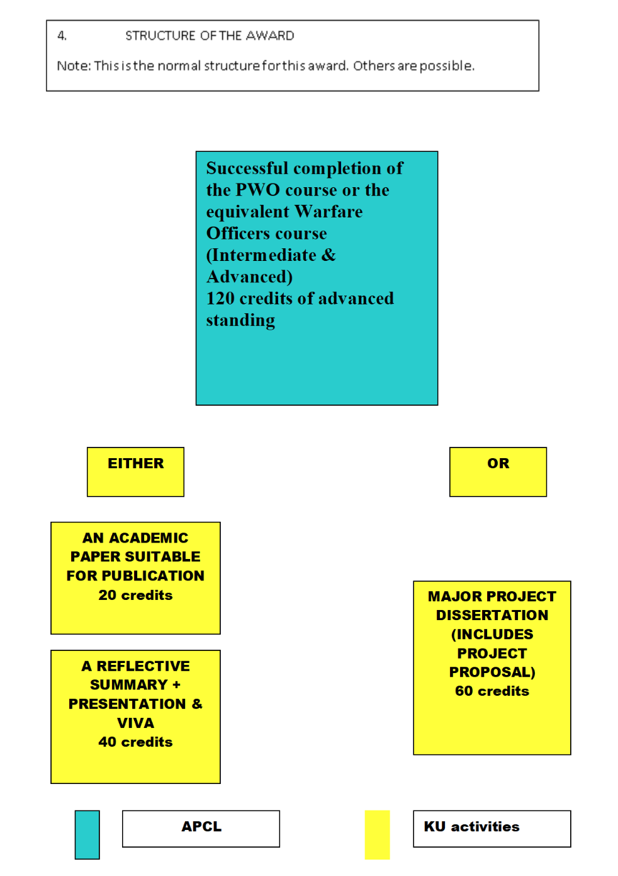

MSc Technology (Maritime Operations)

- Principles of Teaching, Learning and Assessment

Supervision is generally by Skype, email and phone. This is well suited to the mode of study of the students’ who are predominantly naval officers, often on operations.

- Support for Students and their Learning

Students are supported by and Individual tutor who will provide briefing material and formative feedback on draft assignments.
The typical process for individual submissions is as follows:
• Student provided with briefing material followed by discussion with tutor if desired
• Student produces part of/ complete draft as agreed with tutor
• Tutor provides (written) formative feedback followed by discussion with tutor if desired
• Students submits “best & final” for assessment
• Submission is assessed and feedback / mark sheet is sent to student:

- Ensuring and Enhancing the Quality of the Course

The University has several methods for evaluating and improving the quality and standards of its provision. These include:
- External examiners
- Boards of study with student representation
- Annual Monitoring and Enhancement
- Periodic review undertaken at subject level
- Moderation policies
- Feedback from employers

- Employability and work-based learning

As stated above the students on this programme tend to be mid career Naval Officers and so are already in employment.
The students who successfully complete this programme will tend to enhance their employability prospects within their existing organisation as the skill sets that they develop are highly sought after. These skill sets are also likely to be beneficial when the student leaves the Navy to take up a civilian role.

Work-based learning, including sandwich courses and higher or degree apprenticeships

N/A

- Other sources of information that you may wish to consult

N/A

- Development of Course Learning Outcomes in Modules

This table maps where course learning outcomes are summatively assessed across the modules for this course. It provides an aid to academic staff in understanding how individual modules contribute to the course aims, a means to help students monitor their own learning, personal and professional development as the course progresses and a checklist for quality assurance purposes.

Module Code
Knowledge & Understanding | A1
Knowledge & Understanding | A2
Intellectual Skills | B1
Intellectual Skills | B2
Intellectual Skills | B3
Practical Skills | C2
Practical Skills | C1

Students will be provided with formative assessment opportunities throughout the course to practise and develop their proficiency in the range of assessment methods utilised.

