Template C4



Programme Specification

Title of Course: MA Graphic Design

Date first produced | 28/09/2023
Date last revised | 09/05/2025
Status | Live
Date of implementation of current version | 01/09/2025
Version number | 3
Faculty | Kingston School of Art
Cross-disciplinary
School | Design School
Department | Graphic Design
Delivery Institution | Kingston University

This Programme Specification is designed for prospective students, current students, academic staff and employers. It provides a concise summary of the main features of the programme and the intended learning outcomes that a typical student might reasonably be expected to achieve and demonstrate if they take full advantage of the learning opportunities that are provided. More detailed information on the learning outcomes and content of each modules can be found in the course VLE site and in individual Module Descriptors.

SECTION 1: GENERAL INFORMATION

Award(s) and Title(s): | MA Graphic Design
Exit Award(s) and Title(s): | Postgraduate Certificate in Graphic Design  Postgraduate Diploma in Graphic Design
Course Code  For each pathway and mode of delivery | PPGDE1GDE20  PFGDE1GDE20
UCAS code
For each pathway

Award(s) and Title(s): | MA Graphic Design with Professional Placement
Exit Award(s) and Title(s): | PGCert  PGDip
Course Code
For each pathway and mode of delivery
UCAS code
For each pathway

Awarding Institution: | Kingston University
Teaching Institution: | Kingston University
Location: | Knights Park
Language of Delivery: | English
Delivery mode: | Primarily campus based (up to 20% of scheduled L&T hours delivered online)
Learning mode(s): | Full-time  Part-time  With Professional Placement
Minimum period of registration: | Full-time - 1  Part-time - 2  With Professional Placement - 2
Maximum period of registration: | Full-time - 2  Part-time - 4  With Professional Placement - 3
Entry requirements | Kingston University typically uses a range of entry requirements to assess an applicant’s suitability for our courses. Most postgraduate taught course requirements are based on having been awarded a relevant undergraduate degree and are normally coupled with minimum grades expectation of 2:2, specific courses in certain areas may have a stricter grade requirement. We may also use interview, portfolio and performance pieces to assess a person's suitability for some courses. We recognise that every person's journey to a postgraduate taught education is different and unique and in some cases we may take into account work experience and other non-standard pathways onto University level study.  Additionally, all non-UK applicants must meet our English language requirements.  Please see our course pages on the Kingston University website for the most up to date entry requirements.
Regulated by | The University and its courses are regulated by the Office for Students
Programme Accredited by: | N/A
Approved Variants: | N/A
Is this Higher or Degree Apprenticeship course? | No

SECTION 2: THE COURSE

- Aims of the Course

The aims are to:
- Support students to acquire in-depth knowledge and critical understanding of graphic design research methods, contemporary debates and historical principles in an expanded field of practice.
- Co-create a community of practice in which to support students’ analytical, critical, conceptual, and discursive skills through an informed understanding of local and global issues, theoretical studies, and related domains of knowledge.
- Situate risk, play and experimentation as integral components of the design process alongside conceptual depth and within a rigorous academic framework.
- Support students in positioning their own personal practice and future ambitions as agents of change within interconnected and/or intersectional social, cultural, technological, and professional networks and systems.
- Provide dynamic and inclusive studio-based environments in which to analyse and challenge the parameters of graphic design through discussion with peers, tutors and subject experts.
- Apply socio-cultural, ethical and ecological responsibility to innovative design research, thinking and making.
- Enable students to construct and apply diverse modalities of knowledge or experience to the design process by thinking in new ways through design tools and media, audiences, and environments.
- Support students to utilise a range of graduate attributes and transferable skills that will enable them to anticipate and thrive in future professional, academic, or research environments.

The 2-year programme with integrated placement(s) provides students with an opportunity to further enhance their professional skills within an industrial or commercial workplace/environment.

- Programme Learning Outcomes

The programme learning outcomes are the high-level learning outcomes that will have been achieved by all students receiving this award. They have been aligned to the levels set out in ‘Sector Recognised Standards in England’ (OFS 2022).

Programme Learning Outcomes

 | Knowledge and Understanding  On completion of the course students will be able to: |  | Intellectual Skills  On completion of the course students will be able to |  | Subject Practical Skills  On completion of the course students will be able to
A1 | Demonstrate in-depth knowledge and understanding of contemporary and historical practice, research methods, theoretical discourse, ideas, and debates. | B1 | Design and undertake informed, sustained, and rigorous research, investigations and/or enquires and critically evaluate their effectiveness. | C1 | Utilise individual and/or collective practice-based research methodologies and critical making practices.
A2 | Challenge and question parameters of contemporary graphic design discipline and practice. | B2 | Apply theoretical understanding, intellectual reasoning, and ethical positioning to an individual and/or collective practice. | C2 | Produce ambitious and critically challenging work by developing practice, through experimentation, risk, play and open exploration.
A3 | Communicate and articulate critical ideas, reasoning, and intentions effectively through appropriate visual, written and/or oral presentation skills. | B3 | Respond to new and complex problems with individual and/or collective creativity, imagination, innovation, and vision. | C3 | Utilise new, multi-dimensional and/or hybrid modes of design to act as agents of change through graphic design for diverse audiences.
A4 | Apply an understanding of the professional, social, political, and global contexts in which graphic design operates to position own practice and future ambitions. | B4 | Reflect and analyse own achievements and those of others in diverse personal and professional contexts. | C4 | Apply attributes and critical skills required to operate as a design professional, including collaboration, self-advocacy, agency, adaptability, effective communication, relationship building, and project management.

- Future Skills Graduate Attributes

In addition to the programme learning outcomes, the programme of study defined in this programme specification will engage students in developing their Future Skills Graduate Attributes:
- Creative Problem Solving
- Digital Competency
- Enterprise
- Questioning Mindset
- Adaptability
- Empathy
- Collaboration
- Resilience
- Self-Awareness

- Outline Programme Structure

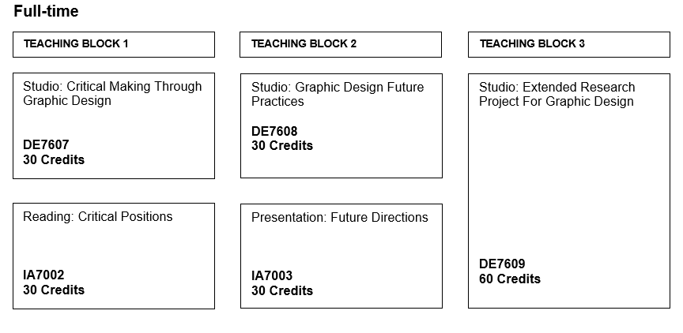
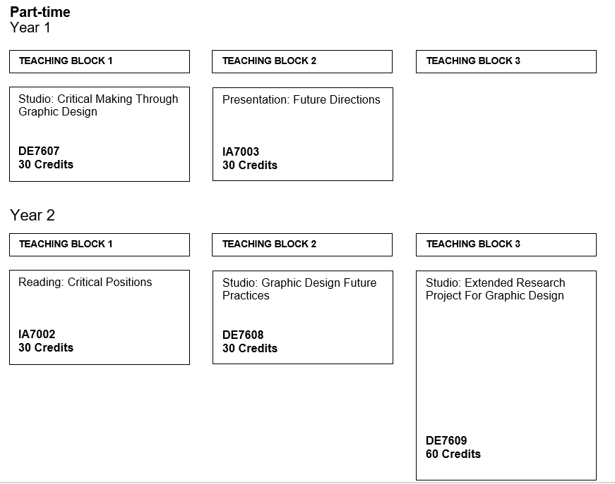

MA Graphic Design

Level 7
MA Graphic Design
Core modules | Module code | Credit  Value | Level | Teaching Block | Pre-requisites | Full Time | Part Time
Presentation: Future Directions | IA7003 | 30 | 7 | TB2 | None | 1 | 1
Reading: Critical Positions | IA7002 | 30 | 7 | TB1 | None | 1 | 2
Studio: Critical Making Through Graphic Design | DE7607 | 30 | 7 | TB1 | None | 1 | 1
Studio: Extended Research Project For Graphic Design | DE7609 | 60 | 7 | TB3 | None | 1 | 2
Studio: Graphic Design Future Practices | DE7608 | 30 | 7 | TB2 | None | 1 | 2
Optional Modules
Professional Placement (Design) | WP7001 | 120 | 7 | TB1,TB2,TB3 | None | 2 | 2

Exit Awards at Level 7

Students exiting the programme with 60 level 7 credits are eligible for the award of Postgraduate Certificate.
Students exiting the programme with 120 level 7 credits are eligible for the award of Postgraduate Diploma.

MA Graphic Design with Professional Placement

- Teaching, Learning and Assessment

This course uses a range of teaching and assessment methods which have been designed to support students’ learning and achievement of the learning outcomes. The course has been developed with reference to the Kingston University Academic Framework which sets-out core principles relating to Course and Credit Structure (including Module delivery Structure and Pattern, and Learning Hours and Learning Formats); Curriculum Design (inclusion Learning Design Principles and Inclusive Curriculum); and Future Skills.

Teaching and Learning on the course consist of Scheduled Learning and Teaching and Guided Independent Study (self-managed time). Scheduled Learning and Teaching includes the following, and the format for each module is set out in the module specification:
- Laboratory Sessions
- Lectures
- Seminars
- Tutorials
- Workshops
- Placements

Guidance for students on the use of independent study time is communicated through the ‘Succeed in your module’ section on the Canvas Virtual Learning Environment and through other communications during the course.

In addition to the core Scheduled Learning and Teaching activities for the course, the University may offer students additional optional opportunities for learning. Examples of these include Study abroad and Work-based learning.

The course will provide students with the opportunity to develop their knowledge and skills relating to at least two United Nations Sustainable Development Goals (UN SDGs). We are committed to empowering students with the knowledge, skills and opportunities to understand and address the UN SDGs: each course is thus also required to prepare students for at least two of the SDGs (not including Quality Education, which all courses must deliver).

- Support for Students and their Learning

Students are supported through a range of services that provide academic and wider support. These include:

- A Module Leader for each module
- A Course Leader to help students understand the course structure
- Personal Tutors to provide academic and personal support
- Technical support to advise students on IT and the use of software
- Student Voice Committee – to ensure the views of students are heard
- Canvas – Kingston University’s Virtual Learning Environment
- Student support facilities that can provide advice on issues such as finance, regulations, legal matters, accommodation, international student support
- Disabled student support
- The Kingston Students’ Union
- Student Development and Graduate Success

- Ensuring and Enhancing the Quality of the Course

The University has policies and procedures for evaluating and improving the quality and standards of its provision. These include:
- Continuous Monitoring of courses through the Kingston Course Enhancement Programme (KCEP)
- Student evaluation including Module Evaluation Questionnaires (MEQs), the National Student Survey (NSS)
- Internal and external moderation of graded assignments

- External Reference Points

External reference points which have informed the design of the course. These include:
- QAA Subject benchmarks
- Other subject or industry standards

- Development of Course Learning Outcomes in Modules

This table maps where programme learning outcomes are summatively assessed across the core modules for this course. It provides an aid to academic staff in understanding how individual modules contribute to the course aims, a means to help students monitor their own learning, personal and professional development as the course progresses and a checklist for quality assurance purposes.

Module Code |  | Level 7
 |  | IA7002 | IA7003 | DE7607 | DE7608 | DE7609
Knowledge & Understanding | A1 | S | S
Knowledge & Understanding | A2 | S | S
Knowledge & Understanding | A3 | S
Knowledge & Understanding | A4 | S |  |  | S
Intellectual Skills | B1 |  |  |  | S
Intellectual Skills | B2 |  |  | S
Intellectual Skills | B3 |  | S | S
Intellectual Skills | B4 |  |  | S
Practical Skills | C1 |  |  | S
Practical Skills | C2 |  |  |  |  | S
Practical Skills | C3 |  |  |  |  | S
Practical Skills | C4 |  | S

Students will be provided with formative assessment opportunities throughout the course to practise and develop their proficiency in the range of assessment methods utilised.

Additional Information

