Template C4



Programme Specification

Title of Course: BSc (Hons) Pharmaceutical Science

Date first produced | 30/09/2012
Date last revised | 27/03/2025
Status | Teaching Out
Date of implementation of current version | 01/09/2025
Version number | 11
Faculty | Faculty of Health, Science, Social Care & Education
Cross-disciplinary
School | School of Life Sciences, Pharmacy and Chemistry
Department | Department of Chemical & Pharmaceutical Sciences
Delivery Institution | Kingston University

This Programme Specification is designed for prospective students, current students, academic staff and employers. It provides a concise summary of the main features of the programme and the intended learning outcomes that a typical student might reasonably be expected to achieve and demonstrate if they take full advantage of the learning opportunities that are provided. More detailed information on the learning outcomes and content of each modules can be found in the course VLE site and in individual Module Descriptors.

SECTION 1: GENERAL INFORMATION

Award(s) and Title(s): | BSc (Hons) Pharmaceutical Science
Exit Award(s) and Title(s): | CertHE Pharmaceutical Science  DipHE Pharmaceutical Science
Course Code  For each pathway and mode of delivery | UFPSC1PSC04
UCAS code  For each pathway | BB22

Award(s) and Title(s): | BSc (Hons) Pharmaceutical Science (with Regulatory Affairs)
Exit Award(s) and Title(s): | CertHE Pharmaceutical Science with Regulatory Affairs  DipHE Pharmaceutical Science with Regulatory Affairs
Course Code  For each pathway and mode of delivery | UFPSR1PSR20
UCAS code
For each pathway

Award(s) and Title(s): | BSc (Hons) Pharmaceutical Science (with Professional Placement)
Exit Award(s) and Title(s): | CertHE Pharmaceutical Science with Professional Placement  DipHE Pharmaceutical Science with Professional Placement
Course Code  For each pathway and mode of delivery | USPSC1PSC45
UCAS code
For each pathway

Award(s) and Title(s): | BSc (Hons) Pharmaceutical Science (with Foundation Year)
Exit Award(s) and Title(s): | CertHE Pharmaceutical Science with Foundation Year  DipHE Pharmaceutical Science with Foundation Year
Course Code  For each pathway and mode of delivery | UFPSC1PSC55
UCAS code
For each pathway

Awarding Institution: | Kingston University
Teaching Institution: | Kingston University
Location: | Penrhyn Road, Kingston upon Thames
Language of Delivery: | English
Delivery mode: | Primarily campus based (up to 20% of scheduled L&T hours delivered online)
Learning mode(s): | Full-time  With Professional Placement
Minimum period of registration: | Full-time - 3  With Professional Placement - 4
Maximum period of registration: | Full-time - 6  With Professional Placement - 8
Entry requirements | Kingston University typically uses a range of entry requirements to assess an applicant's suitability for our courses. Most course requirements are based on UCAS Tariff points, usually stipulated as a range, and are sometimes coupled with minimum grades in specific relevant subjects. We may also use interview, portfolio and performance pieces to assess an applicant's suitability for the course. We recognise that every person's journey to Higher Education is different and unique and in some cases we may take into account work experience and other non-standard pathways onto University level study.  Additionally, all non-UK applicants must meet our English language requirements.  Please see our course pages on the Kingston University website for the most up to date entry requirements
Regulated by | The University and its courses are regulated by the Office for Students
Programme Accredited by: | none
Approved Variants: | There are no variants to UR.
Is this Higher or Degree Apprenticeship course? | No

SECTION 2: THE COURSE

- Aims of the Course

- to provide all students who take the pharmaceutical science course, including those on the regulatory affairs pathway, with an in-depth knowledge and understanding of the core areas of pharmaceutical science.
- to introduce students to the design, synthesis, and development of drugs through the study of appropriate examples.
- to enable students to develop their independent learning skills using primary and secondary literature sources.
- to enable students to develop subject related practical skills.
- to provide students with the opportunity to develop their digital, written, and oral communication skills.
- to prepare students for graduate employment, both scientific and otherwise, and study for a higher degree, whether taught or by research, by developing their intellectual, problem-solving, teamwork and analytical skills.
- Provide students with a comprehensive understanding of the pivotal role pharmaceutical science plays in addressing worldwide health challenges, by encouraging the students to be champions of change.

Additionally for students taking the Regulatory Affairs Pathway:
- to provide students with an in-depth knowledge and understanding of core national and international pharmaceutical regulatory affairs and their application in pharmaceutical manufacturing, enabling students to apply regulatory requirements and guidance to medicines and medicinal products.

Additionally, for those BSc students following the professional placement programme:
- to enable students to complete a period of work experience in an area of pharmaceutical science which is related to their studies and to enhance, using this experience, their knowledge of career opportunities in the academic, pharmaceutical, and related areas.

- Programme Learning Outcomes

The programme learning outcomes are the high-level learning outcomes that will have been achieved by all students receiving this award. They have been aligned to the levels set out in ‘Sector Recognised Standards in England’ (OFS 2022).

Programme Learning Outcomes

 | Knowledge and Understanding  On completion of the course students will be able to: |  | Intellectual Skills  On completion of the course students will be able to |  | Subject Practical Skills  On completion of the course students will be able to
A1 | Demonstrate a good knowledge and understanding of the core areas of pharmaceutical science including organic chemistry, bioanalysis, pharmaceutical chemistry, introductory biology, pharmacology, toxicology and immunology, pharmaceutics and drug delivery. | B1 | Critically analyse and appraise both primary and secondary sources | C1 | Carry out laboratory work in chemistry, life science and related subjects in a safe, competent and professional manner
A2 | Possess the mathematical, statistical and computational skills necessary for working in a scientific capacity in an academic, commercial or industrial context. | B2 | Apply subject knowledge, understanding and empathy in the collaborative solving of global challenges by using inclusive and innovative methods. | C2 | Carry out COSHH safety assessments for any experiment and perform laboratory techniques safely and effectively
A3 | Competently and safely use a variety of modern scientific instruments and computers with dedicated software specific to areas of pharmaceutical science | B3 | Demonstrate the ability to be independent, autonomous learners | C3 | Plan, conduct and report on complex experiments
A4 | Demonstrate a good knowledge and understanding of the regulations applicable to the development, testing and marketing of pharmaceutical products. | B4 | Undertake rigorous data analysis from a variety of sources to discern and establish connections and contradictions. | C4 | Use a range of scientific instruments, understand the principles of their operation and obtain reproducible experimental results
A5 | Introduction to the use of use relevant guidelines for example those from the ICH, EMA, and MHRA | B5 | Demonstrate awareness of the structure and function of the employing company/organisation in relation to the scientific professional environment (Professional Placement route) | C5 | Communicate effectively both orally and in writing by discussing and reflecting on their experience of working in a professional environment (Professional Placement route)
A6 | Develop interpersonal and time management skills by working within a team to achieve organisational goals (Professional Placement route)

- Future Skills Graduate Attributes

In addition to the programme learning outcomes, the programme of study defined in this programme specification will engage students in developing their Future Skills Graduate Attributes:
- Creative Problem Solving
- Digital Competency
- Enterprise
- Questioning Mindset
- Adaptability
- Empathy
- Collaboration
- Resilience
- Self-Awareness

- Outline Programme Structure

Our BSc Pharmaceutical science degrees embed the United Nations Sustainable Development Goals (UNSDGs) to prepare students for impactful careers in the pharmaceutical sector particularly UNSDG 3 - Good Health and Wellbeing, 10 - Reduced Inequalities, 12 – Responsible Consumption and Production and 17 – Partnership for the Goals. Through curricula incorporating aspects of global health / social & environmental sustainability / and ethical approaches to pharmaceutical science practices, students gain a comprehensive understanding of the critical role pharmaceutical science plays in addressing worldwide challenges in health. This approach equips graduates with the knowledge and skills to contribute to sustainable solutions in drug development and healthcare delivery.
Outline Programme Structure
For level 3 modules, see Programme Specification for Foundation Year in Science.

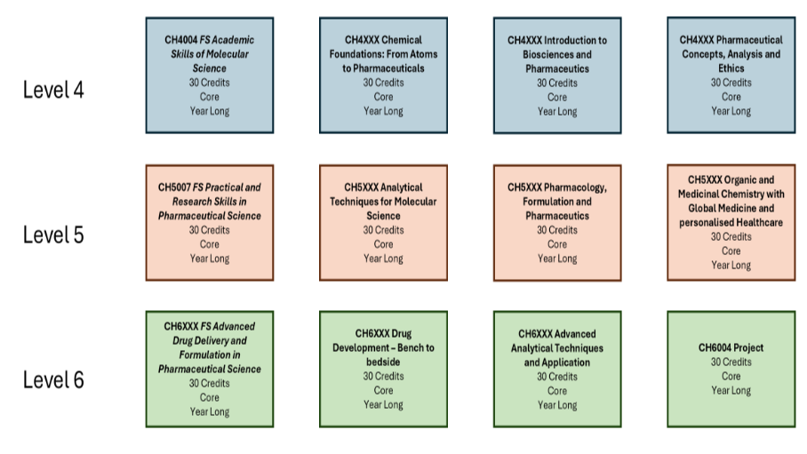

BSc Pharmaceutical Science with Regulatory Affairs

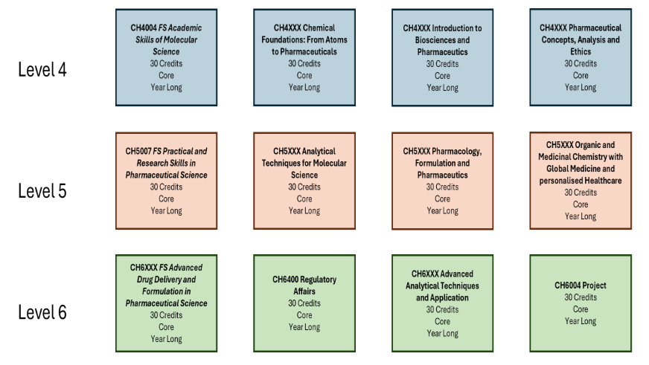

Full details of each module will be provided in module descriptors and in the module canvas pages.

BSc (Hons) Pharmaceutical Science

Level 4
BSc (Hons) Pharmaceutical Science
Core modules | Module code | Credit  Value | Level | Teaching Block | Pre-requisites | Full Time | Part Time
Academic Skills for Molecular Sciences | CH4004 | 30 | 4 | Year long |  | 1
Chemical Foundations: From Atoms to Pharmaceuticals | CH4010 | 30 | 4 | Year long |  | 1
Introduction To Biosciences and Pharmaceutics | CH4008 | 30 | 4 | Year long |  | 1
Pharmaceutical Concepts, Analysis, and Ethics | CH4009 | 30 | 4 | Year long |  | 1

Exit Awards at Level 4

This course permits progression from level 4 to level 5 with 90 credits at level 4 or above. The outstanding 30 credits from level 4 can be trailed into level 5 and must be passed before progression to level 6.

Exit Awards at Level 4
Students exiting the course at this point who have successfully completed 120 credits at level 4 or above are eligible for the award of Certificate of Higher Education.

Level 5
BSc (Hons) Pharmaceutical Science
Core modules | Module code | Credit  Value | Level | Teaching Block | Pre-requisites | Full Time | Part Time
Analytical Techniques for Molecular Science | CH5014 | 30 | 5 | Year long |  | 2
Organic and Medicinal Chemistry with Global Medicine and Personalised Healthcare | CH5010 | 30 | 5 | Year long |  | 2
Pharmacology, Formulation and Pharmaceutics | CH5009 | 30 | 5 | Year long |  | 2
Practical and Research Skills in Pharmaceutical Science | CH5007 | 30 | 5 | Year long |  | 2
Optional Modules
Professional placement | LS5200 | 120 | 5 | Minimum of 36 weeks throughout the year |  | 2

Exit Awards at Level 5

This course permits progression from level 5 to level 6 with 90 credits at level 5 or above. The outstanding 30 credits from level 5 can be trailed into level 6 and must be passed before consideration for an award.

Students who are registered on the professional placement route must successfully complete Levels 4 and 5, before undertaking a period of at least 36 weeks of supervised work experience.

Exit Awards at Level 5
Students exiting the programme at this point who have successfully completed 120 credits at level 5 or above are eligible for the award of Diploma of Higher Education

Level 6
BSc (Hons) Pharmaceutical Science
Core modules | Module code | Credit  Value | Level | Teaching Block | Pre-requisites | Full Time | Part Time
Advanced Analytical Techniques and Applications | CH6011 | 30 | 6 | Year long |  | 3
Advanced Drug Delivery and Formulation in Pharmaceutical Science | CH6014 | 30 | 6 | Year long |  | 3
Drug Development – Bench to Bedside | CH6012 | 30 | 6 | Year long |  | 3
Project | CH6004 | 30 | 6 | Year long |  | 3

Exit Awards at Level 6

Students exiting the programme without completing the full 120 credits but have successfully completed 60 credits at level 6 or above are eligible for the award of an Ordinary Degree.

BSc (Hons) Pharmaceutical Science (with Regulatory Affairs)

Level 4
BSc (Hons) Pharmaceutical Science (with Regulatory Affairs)
Core modules | Module code | Credit  Value | Level | Teaching Block | Pre-requisites | Full Time | Part Time
Academic Skills for Molecular Sciences | CH4004 | 30 | 4 | Year long |  | 1
Chemical Foundations – From Atoms to Pharmaceuticals | CH4007 | 30 | 4 | Year long |  | 1
Introduction To Biosciences and Pharmaceutics | CH4008 | 30 | 4 | Year long |  | 1
Pharmaceutical Concepts, Analysis, and Ethics | CH4009 | 30 | 4 | Year long |  | 1

Exit Awards at Level 4

Students exiting the course at this point who have successfully completed 120 credits at level 4 or above are eligible for the award of Certificate of Higher Education.

Level 5
BSc (Hons) Pharmaceutical Science (with Regulatory Affairs)
Core modules | Module code | Credit  Value | Level | Teaching Block | Pre-requisites | Full Time | Part Time
Analytical Techniques for Molecular Science Practical and Research Skills in Pharmaceutical Science | CH5011 | 30 | 5 | Year long |  | 2
Analytical Techniques for Molecular Science Practical and Research Skills in Pharmaceutical Science | CH5011 | 30 | 5 | Year long |  | 2
Organic and Medicinal Chemistry with Global Medicine and Personalised Healthcare | CH5010 | 30 | 5 | Year long |  | 2
Pharmacology, Formulation and Pharmaceutics | CH5009 | 30 | 5 | Year long |  | 2

Exit Awards at Level 5

This course permits progression from level 5 to level 6 with 90 credits at level 5 or above. The outstanding 30 credits from level 5 can be trailed into level 6 and must be passed before consideration for an award.

Students who are registered on the professional placement route must successfully complete Levels 4 and 5, before undertaking a period of at least 36 weeks of supervised work experience.

Exit Awards at Level 5
Students exiting the programme at this point who have successfully completed 120 credits at level 5 or above are eligible for the award of Diploma of Higher Education.

Level 6
BSc (Hons) Pharmaceutical Science (with Regulatory Affairs)
Core modules | Module code | Credit  Value | Level | Teaching Block | Pre-requisites | Full Time | Part Time
Advanced Analytical Techniques and Applications | CH6011 | 30 | 6 | Year long |  | 3
Advanced Drug Delivery and Formulation in Pharmaceutical Science | CH6014 | 30 | 6 | Year long |  | 3
Project | CH6004 | 30 | 6 | Year long |  | 3
Regulatory Affairs For Pharmaceutical Science | CH6400 | 30 | 6 | Year long |  | 3

Exit Awards at Level 6

Students exiting the programme without completing the full 120 credits but have successfully completed 60 credits at level 6 or above are eligible for the award of an Ordinary Degree.

BSc (Hons) Pharmaceutical Science (with Professional Placement)

BSc (Hons) Pharmaceutical Science (with Foundation Year)

- Teaching, Learning and Assessment

This course uses a range of teaching and assessment methods which have been designed to support students’ learning and achievement of the learning outcomes. The course has been developed with reference to the Kingston University Academic Framework which sets-out core principles relating to Course and Credit Structure (including Module delivery Structure and Pattern, and Learning Hours and Learning Formats); Curriculum Design (inclusion Learning Design Principles and Inclusive Curriculum); and Future Skills.
Teaching and Learning on the course consist of Scheduled Learning and Teaching and Guided Independent Study (self-managed time). Scheduled Learning and Teaching includes the following, and the format for each module is set out in the module specification:
- Laboratory Sessions
- Lectures
- Seminars
- Tutorials
- Workshops
- Placements
Guidance for students on the use of independent study time is communicated through the ‘Succeed in your module’ section on the Canvas Virtual Learning Environment and through other communications during the course.
In addition to the core Scheduled Learning and Teaching activities for the course, the University may offer students additional optional opportunities for learning. Examples of these include Study abroad and Work-based learning.
The course will provide students with the opportunity to develop their knowledge and skills relating to at least two United Nations Sustainable Development Goals (UN SDGs). We are committed to empowering students with the knowledge, skills and opportunities to understand and address the UN SDGs: each course is thus also required to prepare students for at least two of the SDGs (not including Quality Education, which all courses must deliver).

- Support for Students and their Learning

Students are supported through a range of services that provide academic and wider support. These include:

- A Module Leader for each module
- A Course Leader to help students understand the course structure
- Personal Tutors to provide academic and personal support
- Technical support to advise students on IT and the use of software
- Student Voice Committee – to ensure the views of students are heard
- Canvas – Kingston University’s Virtual Learning Environment
- Student support facilities that can provide advice on issues such as finance, regulations, legal matters, accommodation, international student support
- Disabled student support
- The Kingston Students’ Union
- Student Development and Graduate Success
- Careers and Employability Service, including a Faculty employability co-ordinator
- A Placements administrator
- Peer Mentoring Scheme (for which the Course Leader is a Champion)
- The Library, which includes the four on campus libraries as well as an online library and other e-resources
- The Academic Success Centre (ASC) that provide specific academic support on academic writing, study skills and maths
- LinkedIn Learning embedded into the curriculum and as part of the PTS

- Ensuring and Enhancing the Quality of the Course

The University has policies and procedures for evaluating and improving the quality and standards of its provision. These include:
- Continuous Monitoring of courses through the Kingston Course Enhancement Programme (KCEP)
- Student evaluation including Module Evaluation Questionnaires (MEQs), the National Student Survey (NSS)
- Internal and external moderation of graded assignments
- Academy of Pharmaceutical Science

- External Reference Points

- The Academy of Pharmaceutical Scientists – APS - (www.apsgb.co.uk)
- The Organisation for Professionals in Regulatory Affairs - TOPRA - (www.topra.org)

- Development of Course Learning Outcomes in Modules

This table maps where programme learning outcomes are summatively assessed across the core modules for this course. It provides an aid to academic staff in understanding how individual modules contribute to the course aims, a means to help students monitor their own learning, personal and professional development as the course progresses and a checklist for quality assurance purposes.

Module Code |  | Level 4 |  |  |  |  | Level 5 |  |  |  |  |  | Level 6
 |  | CH4008 | CH4009 | CH4004 | CH4010 | CH4007 | CH5009 |  | CH5010 | CH5007 | CH5011 | CH5014 | CH6400 |  | CH6004 | CH6014 | CH6012 | CH6011
Knowledge & Understanding | A1 |  |  |  |  | S |  |  |  |  |  |  | S |  |  | S |  | S
Knowledge & Understanding | A2 | S |  | S |  |  | S |  | S |  |  | S
Knowledge & Understanding | A3 |  | S |  |  | S |  |  |  |  |  |  | S |  |  |  |  | S
Knowledge & Understanding | A4 |  |  |  |  |  | S |  |  |  | S | S | S |  |  |  | S
Knowledge & Understanding | A5 |  | S |  |  |  |  |  | S |  | S |  |  |  | S
Knowledge & Understanding | A6 |  |  | S |  |  |  |  |  |  |  | S
Intellectual Skills | B1 |  |  |  |  | S |  |  |  |  |  | S |  |  |  | S |  | S
Intellectual Skills | B2 |  |  | S |  | S | S |  |  |  | S |  | S |  |  |  | S
Intellectual Skills | B3 | S | S |  |  |  |  |  | S |  |  | S |  |  |  | S
Intellectual Skills | B4 |  |  | S |  | S |  |  | S |  |  | S |  |  |  |  |  | S
Intellectual Skills | B5 | S | S |  |  |  |  |  |  |  | S |  |  |  | S
Practical Skills | C1 | S | S |  |  |  |  |  | S |  | S |  | S |  |  | S |  | S
Practical Skills | C2 |  |  | S |  |  | S |  |  |  |  |  |  |  | S |  |  | S
Practical Skills | C3 |  |  |  |  | S |  |  |  |  | S | S |  |  | S
Practical Skills | C4 |  | S | S |  | S |  |  | S |  | S |  |  |  |  | S |  | S
Practical Skills | C5 | S |  | S |  |  |  |  | S |  |  |  | S |  | S |  | S

Students will be provided with formative assessment opportunities throughout the course to practise and develop their proficiency in the range of assessment methods utilised.

Additional Information

