Template C4



Programme Specification

Title of Course: MSc Software Engineering

Date first produced | 30/04/2016
Date last revised | 06/02/2026
Status | Live
Date of implementation of current version | 01/09/2025
Version number | 10
Faculty | Faculty of Engineering, Computing and the Environment
Cross-disciplinary
School | School of Computer Science and Mathematics
Department | Department of Computer Science
Delivery Institution | ESOFT Metro Campus, Sri Lanka

This Programme Specification is designed for prospective students, current students, academic staff and employers. It provides a concise summary of the main features of the programme and the intended learning outcomes that a typical student might reasonably be expected to achieve and demonstrate if they take full advantage of the learning opportunities that are provided. More detailed information on the learning outcomes and content of each modules can be found in the course VLE site and in individual Module Descriptors.

SECTION 1: GENERAL INFORMATION

Award(s) and Title(s): | MSc Software Engineering
Exit Award(s) and Title(s): | Postgraduate Diploma Software Engineering  Postgraduate Certificate Software Engineering
Course Code
For each pathway and mode of delivery
UCAS code  For each pathway | G600

Awarding Institution: | Kingston University
Teaching Institution: | ESOFT Metro Campus, Sri Lanka
Location: | ESOFT Metro Campuses in Colombo, Kandy and Jaffna
Language of Delivery: | English
Delivery mode:
Learning mode(s): | Part-time  Full-time
Minimum period of registration: | Part-time - 2  Full-time - 1
Maximum period of registration: | Part-time - 4  Full-time - 2
Entry requirements | Applicants for the MSc programme are normally required to have a good honours degree in IT, Computer Science, Software Engineering or the academic equivalent.  Exceptionally applicants may have no first degree but 5+ years working in a software design and development area. In this case, there must be strong evidence that the applicant has the motivation to complete the course and the ability to work at this level.  Both of these types of applicants will benefit from the advanced and specialised nature of the technical and business knowledge covered in the course that is designed to build on the knowledge they already possess.  Overseas students are required to satisfy the Admissions Officer that they have reached an equivalent academic standard as those required for home students.  Language Requirements  IELTS – minimum 6.5 overall, including a minimum of 6.0 in writing, and a minimum of 5.5 in reading, listening and speaking  TOEFL IBT with overall score of 88, inc min score of 20/30 Writing, 20/30 Reading, 17/30 Listening and 20/30 Speaking  Kingston University also approved the following mapping as equivalent alternatives to IELTS requirements for entry into franchised programmes to be delivered at ESOFT in Sri Lanka;  - Local GCE O Level English language: Credit, Distinction or Very good pass  - ESOFT English for Academic Purposes modules in reading, writing, listening and speaking: results which equate to our normal entry conditions in the following ways (*NB: The overall grade to be an average of the four skills module results.)
  IELTS | ESOFT
  6.5 | 58+
  6.0 | 50-57
  5.5 | 42-49
Regulated by | The University and its courses are regulated by the Office for Students
Programme Accredited by: | Non-accredited programme
Approved Variants: | Compensation not permitted.
Is this Higher or Degree Apprenticeship course? | No

SECTION 2: THE COURSE

- Aims of the Course

The Aims of the Course are to:
- Equip students with the capability to exploit software engineering methods, tools and design skills which will enable them to design and develop applications for organisations in the 21st century.
- Enhance a student’s job performance and enable him/her to contribute effectively to the knowledge base of the employer.
- Give students the means to explore in detail the technical delivery architecture, systems integration, and consumer facing software systems.
- Maintain productive links with industry which provide sufficient background for an industrial/commercial dimension to the course.
- Undertake continuing professional development and updating for established IT professionals.
- Implant an enquiring, analytical and creative approach to both personal and professional activities that leads to the critical and responsible use of informed and independent judgement.
- Undertake a more effective role in software systems design and development.
- Gain a solid foundation in this specialist area, building on knowledge and skills gained from students individual backgrounds.
- Have an in-depth understanding of the new software development strategies and architectures appropriate to the design of Internet-oriented applications.
- Have an opportunity to study a subject area which is relevant to the field but also satisfies the individual's background and experience.
- Have the ability to apply specialised knowledge and skills to the analysis and solution of novel problems in commerce and the industry.

- Programme Learning Outcomes

The programme learning outcomes are the high-level learning outcomes that will have been achieved by all students receiving this award. They have been aligned to the levels set out in ‘Sector Recognised Standards in England’ (OFS 2022).

Programme Learning Outcomes

 | Knowledge and Understanding  On completion of the course students will be able to: |  | Intellectual Skills  On completion of the course students will be able to |  | Subject Practical Skills  On completion of the course students will be able to
A5 | the processes necessary to assure the quality of complex systems, and to select, configure and utilise tools for cost effective development | B6 | Specify and design systems architecture as appropriate and consider necessary trade-offs between centralised and distributed architectures | C5 | Assess the quality of software and optimise the process of its production
A4 | The tools and technologies necessary for business application design and development. | B5 | Build upon the experience and responsibility gained as a result of the practical application of the skills acquired during the course to make a significant contribution as a computing or information systems professional within an organization | C4 | Design optimal software architectures using appropriate methods and technologies
A2 | The ethical, legal and professional issues in the development of software applications | B2 | Understand and define the business context that software applications can sit within, and across (e.g. a collaborative service scenario). | C3 | Evaluate and select appropriate software engineering tools for a software development project.
A1 | Current developments in Software Engineering and their potential and limitations | B3 | Critically analyse and evaluate research in the chosen area. | C2 | Specify software that meets the needs and aspiration of the users. This specification should include a conceptual data model for Web business applications, identifying entities and attributes, using a recognised notation.
A3 | Software engineering principles and practical techniques required for the design and development of Web business applications | B1 | Learn independently, think logically and critically and demonstrate a systematic approach to problem-analysis and to finding solutions. | C1 | Select and use effectively a wide range of methods, tools and techniques used in the design and development of software applications.
 |  | B4 | Identify current issues in the area of software engineering

- Future Skills Graduate Attributes

In addition to the programme learning outcomes, the programme of study defined in this programme specification will engage students in developing their Future Skills Graduate Attributes:
- Creative Problem Solving
- Digital Competency
- Enterprise
- Questioning Mindset
- Adaptability
- Empathy
- Collaboration
- Resilience
- Self-Awareness

- Outline Programme Structure

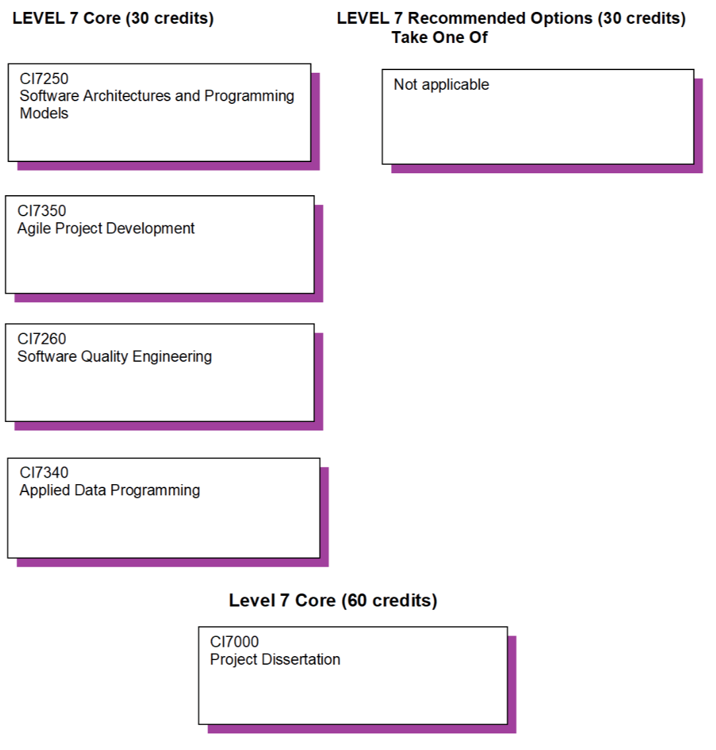
Full time students: Complete four modules over two Teaching Blocks (TB), two modules per TB. Complete the Core Modules and the Project Dissertation in the same academic year.

Part time students: Complete four modules over four TBs, one module per TB (Two modules per academic year) and project Dissertation in the second academic year. Complete the Core Modules and the Project Dissertation within two academic years.

TB1 for January intake is typically January to April, TB2 is September to December
TB1 for September intake is typically September to December, TB2 is January to April

Project Dissertation Start/End:
January intake: starts in May, Submission in January
September intake: starts in April, Submission in September

The programme is made up of four modules each worth 30 credit points plus a capstone project worth 60 credits. All students will be provided with the Kingston University regulations. Full details of each module will be provided in module descriptors and student module guides.

Level 7 requires the completion of the four compulsory modules.

MSc Software Engineering

Level 7
MSc Software Engineering
Core modules | Module code | Credit  Value | Level | Teaching Block | Pre-requisites | Full Time | Part Time
Agile Project Development | CI7350E | 30 | 7 | 1
Applied Data Programming | CI7340 | 30 | 7 | Ty13 |  | 1 | 2
Project Dissertation | CI7000E | 60 | 7 | 1 and 2
Software Architecture and Programming Models | CI7250E | 30 | 7 | 1
Software Quality Engineering | CI7260E | 30 | 7 | 2

Exit Awards at Level 7

PLEASE DELETE IF THERE ARE NO LEVEL 7 MODULES IN THIS COURSE
Students exiting the programme with 60 level 7 credits are eligible for the award of Postgraduate Certificate.
Students exiting the programme with 120 level 7 credits are eligible for the award of Postgraduate Diploma.
(Where appropriate – specify if there are any core modules that students must achieve for either of the exit awards)
Please note pre-requisite requirements for master’s courses should only be set where there are defined progression points in the course where assessment boards have ratified module outcomes.

- Teaching, Learning and Assessment

The School’s broad strategy of aiming for problem-centred teaching and accessible, relevant (authentic) artefact-based assessment (assessment of learning by doing/creating) was created in recognition of this. The course adopts the University’s Inclusive Curriculum Design Principles to cater for this diversity and define the approaches to learning, teaching and assessment (LTA), pastoral care and employability with the following broad principles:

- An inclusive curriculum with the student at the heart of the learning process encouraging choice in their focussed topics for investigation within the prescribed module assignment formats (where practical) and sharing experiences and perspectives within the course through discussion and presentation of results.
  - Module descriptors adopt problem-centred approaches which in turn facilitate an inclusive learning environment.
  - Curricula and approaches to LTA allow for expression of cohorts’ experiences and perspectives, ultimately for sharing and shaping understanding together. Modules and the dissertation challenge students’ epistemological and ontological approaches to the study of Software Engineering, including software and its legal, social and ethical aspects, data presentation and the impact on society and the interpretation of business strategy and the development of information systems to support the business. Also to develop approaches to critical evaluation of current and future knowledge.
  - Teaching sessions are problem-centred, predominantly workshop-based, and necessarily interactive to make best use of the intensive weeks of study interspersed with directed study. Workshops and the use of the VLE (or other cohort-inspired networking tools) allow students to investigate and share their understanding of new concepts, techniques and technologies. This approach is also designed to enhance their practical competency and confidence when dealing with a range of “users” (recognising the diversity of Software Engineering teams and roles).
  - The delivery is research informed, taking advantage of CSM’s diverse research portfolio, dynamically updated in accordance with advances in the field.
  - Modules incorporate opportunities to explore current developments in the field, in practice and applied settings incorporating student perspectives, real world situations, problem solving and task based learning. Content includes the opportunity for students to personalise the topics being explored and allow them to adapt summative assessments towards their personal interests and motivations, where practical
  - Teaching teams draw on the academic strengths and research interests of staff and use invited speakers and experts from research and industry to bolster the curriculum. This offers students up-to-date learning experiences from experts in these areas.
  - Students complete their MSc by conducting an individualised capstone research project, designed in collaboration with the Software Engineering team.
- Assessment for learning (rather than solely of learning) enabling an inclusive student perspective in their design and application, permitting a degree of individual choice and direction for assessed tasks work.
  - All assessments have been designed at level 7, as appropriate for the Information System MSc, to be inclusive, accessible, artefact-based and authentic to the field.
  - Students’ induction at the start of the course includes an introduction to the language of UK HEI assessment and the tools used to measure the quality of their academic performance.
  - The assessment strategy aims to incorporate an element of choice within a carefully designed framework of assessments that align with the diversity of an Information Systems’ student needs, and thus encourages students to be personally involved in their assessments. For example, students will have opportunities to choose to work with datasets reflecting their specialism or areas of interest in coursework assignments, provided the data is publicly available and appropriately licensed.
  - Students have formative tasks and feedback available within the workshops preceding all assessments. Teaching sessions adopt a range of activities (including practical tasks, case studies, group discussion, role play) to enrich the learning experience in a problem-centred, predominantly workshop-based setting, which directly supports the formulation of summative assessments.
  - Feedback on both formative tasks and summative work enables students to learn from assessment experiences, reflect alongside directed study and feed-forward that learning to future assessments, most critically to the final dissertation project.
- An approach to the personal tutor system appropriate to the Software Engineering MSc, which provides opportunities for students to personalise their experience and track their academic and personal skills development.
  - The Course Leader is the nexus of the postgraduate personal tutor system and normally acts as the formal Personal Tutor, supported day-to-day during intensive week-block teaching by the course’s module leaders.
  - Students will have a Dissertation Supervisor from the Software Engineering team and in cases where that is the Course Leader, an independent Personal Tutor will also be appointed so that all students have the opportunity for independent pastoral and academic advice.
  - The Course Leader and/or Personal Tutor will meet with Software Engineering students regularly to provide guidance on assessment and personal development choices, discuss progress on the course, career plans, goals, development and recognition of personal and graduate attributes.

The course ensures that the students are exposed to team working through group presentations, joint report writing, joint research and lab work. The students develop presentation and communication skills through these activities as well as practise analytical thinking, focused literature reviewing and academic essay writing, as part of their coursework portfolio. In this way, they also improve their research and evaluation skills. The student is required to further explore and exploit the information given in the modules through guided self-study.

Capstone Project
Students will be given close guidance to select a project that is relevant to their background and specialisation. During the project, the student will be expected to apply the knowledge acquired during the course. Key skills in communication, presentation, literature search, problem analysis, project planning, report writing and solution justification are all part of the learning outcomes defined in this course.

Contact Time
The programme consists of modules in which the learning outcomes are achieved through a combination of scheduled tutor lead activities and practice. Scheduled contact time with students given within each module guide consists of lectures, tutorials, and practical sessions. Contact with staff often takes place in the context of giving feedback on assessed work but will not necessarily be scheduled.

Virtual Learning Environment (VLE)
Kingston University uses Canvas learning management system (VLE), which is used extensively in all modules as a means of dissemination of lecture notes, worksheets, assignments, reference materials, links, videos and lecturer annotated slides. In this way it acts as a repository for learning materials to be used by the students for independent study and in addition in some modules, for formative and summative tests and surveys. In addition, EMC will make use of the Esoft-VLE to share learning materials when required, minimising the effect of technical or geographical limitations.
Assessment and Feedback
The use of a variety of assessment methods is adopted as an appropriate assessment strategy to ensure all aspects of learning outcomes are covered and achieved. In particular:
- A portfolio of coursework assignments is designed to develop analytical and practical skills in a student,
- An unseen exam is designed to develop skills required in problem solving situations, commonly found in practice.

The formative assessment is used to help students answer particular components of the assessment by giving them timely feedback on exercises specially designed to simulate the exam questions or elements of the coursework assignments. The feedback is provided in:
- A written form thus presenting an additional learning resource helping the student build the knowledge throughout the learning process and prepare for the summative assessment.
- The exercises may take various forms including:
  - small building projects,
  - essay writing or
  - analysing past exam questions

At the end of the course every student undertakes a project dissertation which is a significant activity that draws on and enhances the skills and knowledge developed throughout the programme. As such, the assessment places greater emphasis on the ability to plan work, manage time effectively, and research background information, culminating in portfolio of written reports and an interview
n the programme as a whole, the assessment components as outlined in the Section C, under the Teaching/Learning and Assessment Strategies heading are used in all of the modules.

Research Informed Teaching

Module leaders and teaching staff responsible for programme delivery at ESOFT are practitioners and experts in their respective fields, and are maintaining strong academic and industrial links locally and overseas. Kingston University’s School of Computer Science and Mathematics has a number of leading research teams and output from their work is used to inform the content of learning materials, case studies and practical exercises etc., used within the taught degree. This ensures that the currency of the content is maintained and that it reflects the latest technology, thinking and practice. For example, Research in Software Engineering is focused in the Component and Distributed Systems Research Group (CODIS). The group conducts research into software quality modelling and software architectures supporting distributed service oriented scientific and enterprise applications. The research targets diverse environments, ranging from Cloud Computing to dedicated scalable high performance clusters with a special focus on the management of system resources and distributed services. In addition the CODIS is developing generic software quality models and metrics that allow meeting not only users’ functional requirements but also their non-functional requirements in the form of Quality of Service (QoS). The group is also developing new solutions for the integrated management of data, information and knowledge using service oriented, component and distributed technologies. Moreover, aspects of usability as a software quality factor are conducted within the User Experience Research Group. The Digital Media for HealthCare Group has developed, for example, systems for personalised healthcare, mobile applications, and quality of service management in 4G networks. The Digital Information Research Centre has developed applications for querying databases of CCTV footage, and for controlling distributed networks of cameras.

Therefore the expertise and research awareness of staff from both institutions feeds through to support learning in lectures and other forms of student engagement during contact time. It is also expected that both students and staff from the two institutions would be actively seeking opportunities to establish research collaborations.

- Support for Students and their Learning

Students are supported by:
Students are supported by a highly qualified team of academic staff that includes individuals in the following roles:
- A Course Director to help students understand the programme structure
- A Personal Tutor to help and guide the student throughout the course
- A Module Leader for each module

Additional support is provided by the following specialist staff:
- Technical Support to advise students on IT and the use of software
- A designated Programme Administrator
- English language support if required

Matters outside the academic arena are supported by:
- Student support facilities that provide advice on issues such as finance, regulations, legal matters, accommodation, international student support etc.
- An induction week at the beginning of each new academic session
- Staff Student Consultative Committee
- Canvas a versatile on-line interactive learning management system available on the university’s intranet
Support for Academic Skills
The Student Support Team help students with any problem which has an effect on their studies. This can range from illness, problems writing an assignment, questions about academic regulations to serious confidential issues.
The students are introduced to all these mechanisms during induction sessions at the beginning of each new academic year. It is here that the students first encounter the university’s computer network, which includes their personal access to Canvas and how to use it as a learning environment.
Students are expected to be involved in the development of their programme. On an individual level through meetings with their course director/personal tutor at which they can discuss their academic progress, personal development and can seek advice on course and module choices in the light of their career aspirations. As a cohort, students can contribute to many aspects of programme evolution, for example by student representation on committees including Staff Student Consultative Committees as well as by their formal and informal feedback such as the mid-module and end-of-module reviews.

The Personal Tutoring Scheme
A Personal Tutor is allocated to each MSc student. Personal Tutors are recruited from the Course team – to ensure the students have the opportunity to benefit from various aspects of the profession that each individual academic brings. The personal tutors will meet with their students sufficiently frequently to maintain close communication and manage to provide information/advise on the matters relevant at the start of the course, address the progression and advise on the personal development leading to relevant career choices. Typically, there will be at least 2 individual meetings per teaching block, specifically at:
- The start of the teaching block to discuss the work patterns on the course and/or the choice of electives
- At the end of the teaching block to review the progress of individual students
There are also planned group meetings – one per teaching block – to discuss issues of common interest. At each of these meetings the students are encouraged to raise issues of their concern so that they can be resolved effectively and timely in due course.
Level 7: Getting the most out of the Masters
- To help students to make the transition to Masters level study and understand how to use feedback on the postgraduate course
- To encourage students to be proactive in making links between their course and their professional and/or academic aspirations
- To explore students’ research aspirations
- To help students gain confidence in contributing to, and learning from, constructive peer review
- To encourage students to become part of a wider disciplinary and/or professional community
- To help students to prepare for the dynamics of supervision

- Ensuring and Enhancing the Quality of the Course

The University has several methods for evaluating and improving the quality and standards of its provision. These include:
- External examiners
- Boards of study with student representation
- Annual Monitoring and Enhancement
- Periodic review undertaken at subject level
- Student evaluation including Module Evaluation Questionnaire (MEQs), level surveys and the National Student Survey (NSS)
- Moderation policies
- Feedback from employers

- External Reference Points

External reference points which have informed the design of the course. These include:
- PSRB standards
- QAA Subject benchmarks
- Apprenticeship standards
- Other subject or industry standards
Please delete or edit as required, for example if course is not an Apprenticeship then delete 'Apprenticeship standards'.

- Development of Course Learning Outcomes in Modules

This table maps where programme learning outcomes are summatively assessed across the core modules for this course. It provides an aid to academic staff in understanding how individual modules contribute to the course aims, a means to help students monitor their own learning, personal and professional development as the course progresses and a checklist for quality assurance purposes.

Module Code |  | Level 7
 |  | CI7260E | CI7350E | CI7000E | CI7250E | CI7340
Knowledge & Understanding | A5 | S |  | S | S
Knowledge & Understanding | A4
Knowledge & Understanding | A2 | S |  | S | S
Knowledge & Understanding | A1 | S |  | S | S
Knowledge & Understanding | A3 | S |  | S | S
Intellectual Skills | B6 | S |  |  | S
Intellectual Skills | B5 | S |  | S | S
Intellectual Skills | B2 | S | S | S | S
Intellectual Skills | B3 | S | S | S | S
Intellectual Skills | B1 | S | S | S | S
Intellectual Skills | B4 | S | S | S | S
Practical Skills | C5 | S |  | S | S
Practical Skills | C4 | S |  | S | S
Practical Skills | C3 |  |  | S
Practical Skills | C2 | S |  | S | S
Practical Skills | C1 | S | S | S | S

Students will be provided with formative assessment opportunities throughout the course to practise and develop their proficiency in the range of assessment methods utilised.

Additional Information

Add information here about the number of approved entry points and for each one, except the first one, the delivery dates of the modules and which Teaching Block they’ll be delivered in. The details of the first entry point noted should be provided in the module tables above.

Standard Codes and Definitions for Teaching Blocks
• TY13
Module taught across Autumn and Spring terms.
Example: 29 Sept 2025 – 24 Apr 2026.
• TB1
Autumn term only.
Example: 29 Sept 2025 – 19 Dec 2025.
• TB2
Spring term only.
Example: 12 Jan 2026 – 24 Apr 2026.
• TB3
Summer term only.
Example: 25 May 2026 – 24 Jul 2026.
• SPAN
Module spans two academic years.
• Internally recorded as SPAN1 (first part) and SPAN2 (second part) in SITS.
• For CMS entries, using SPAN is sufficient as long as the team understands it covers two academic years.
Example: 1 May 2025 – 1 Sept 2026.
• ACYR
Module taught within dates that do not fit standard slots.
Example: 1 Aug 2025 – 1 Oct 2025.

