Template C4



Programme Specification

Title of Course: BSc (Hons) Retail Leadership Degree Apprenticeship

Date first produced | 13/09/2024
Date last revised | 10/01/2025
Status | Live
Date of implementation of current version | 01/05/2028
Version number | 2
Faculty | Faculty of Business and Social Sciences
Cross-disciplinary
School | Kingston Business School
Department | Department of Management
Delivery Institution

This Programme Specification is designed for prospective students, current students, academic staff and employers. It provides a concise summary of the main features of the programme and the intended learning outcomes that a typical student might reasonably be expected to achieve and demonstrate if they take full advantage of the learning opportunities that are provided. More detailed information on the learning outcomes and content of each modules can be found in the course VLE site and in individual Module Descriptors.

SECTION 1: GENERAL INFORMATION

Award(s) and Title(s): | BSc (Hons) Retail Leadership Degree Apprenticeship
Exit Award(s) and Title(s): | Ordinary Degree in Retail Leadership Degree Apprenticeship (Integrated)  Certificate in higher Education in Retail Leadership  Diploma in Higher Education in Retail Leadership
Course Code  For each pathway and mode of delivery | UORLA1RLA77
UCAS code  For each pathway | NA

Awarding Institution: | Kingston University
Teaching Institution:

Location: | Kingston Hill
Language of Delivery: | English
Delivery mode:
Learning mode(s): | Full-time
Minimum period of registration: | Full-time - 4 years
Maximum period of registration: | Full-time - 8 years
Entry requirements | Kingston University typically uses a range of entry requirements to assess an applicant's suitability for our courses. Most course requirements are based on UCAS Tariff points, usually stipulated as a range, and are sometimes coupled with minimum grades in specific relevant subjects. We may also use interview, portfolio and performance pieces to assess an applicant's suitability for the course. We recognise that every person's journey to Higher Education is different and unique and in some cases we may take into account work experience and other non-standard pathways onto University level study.  Maths and English GCSE minimum Grade 4 must be achieved in English and Maths prior to starting the course  Additionally, all non-UK applicants must meet our English language requirements.  Please see our course pages on the Kingston University website for the most up to date entry requirements.
Regulated by | The University and its courses are regulated by the Office for Students.
Programme Accredited by: | N/A
Approved Variants: | N/A
Is this Higher or Degree Apprenticeship course? | Yes

For Higher or Degree Apprenticeship proposals only

Higher or Degree Apprenticeship standard: | ST 0547 Retail Leadership Apprenticeship Standards
Recruitment, Selection and Admission process: | Apprentices will be recruited by the employer whereupon the KU apprenticeship team will invite all applicants to undertake an Initial Needs Assessment (INA). Following this assessment, an online interview will be arranged. Successful applicants are given a conditional offer to the course. Once this has been accepted, KU sends out enrolment communication. Upon successful enrolment, the apprentice will receive a KU ID and access to Canvas.
End Point Assessment Organisation(s): | Kingston University

SECTION 2: THE COURSE

- Aims of the Course

- develop in learners knowledge of retail that enables them to pursue a graduate level career in the sector
- Prepare future retail leaders to develop the skills required to face the challenges of leading in a dynamic retail environment
- support learners to be critical thinkers, who can challenge and innovate
- support learners to successfully plan and execute a work-based project
- develop a passion in learners to work in the retail sector

- Programme Learning Outcomes

Programme Learning Outcomes

 | Knowledge and Understanding  On completion of the course students will be able to: |  | Intellectual Skills  On completion of the course students will be able to |  | Subject Practical Skills  On completion of the course students will be able to
A1 | Explain and critically evaluate complex retail business environments | B1 | Use data to identify and solve unstructured business problems, and make evidence-based decisions | C1 | Implement current and emerging digital and technological solutions
A2 | Communicate an in-depth knowledge and understanding and of the key functional business areas within retail | B2 | Use an enterprising mindset to create value across the organisation. | C2 | Identify business opportunities and make a difference
A3 | Apply a detailed and critical understanding of how retail business elements interrelate and affect overall organisational performance | B3 | Interpret, analyse, evaluate and draw inferences from business information and other relevant information sources to aid decision making in the workplace | C3 | Work effectively in diverse environments, and with others and get things done
A4 | Apply a critical awareness and understanding of current issues of global concern such as sustainability, ethics, social responsibility and technology and how these relate to contemporary retail practice | B4 | Use relevant critical or creative skills to deal with management problems and issues to produce recommendations for decision and subsequent action | C4 | Conduct and present themselves in a professional manner appropriate for the workplace

- Future Skills Graduate Attributes

In addition to the programme learning outcomes, the programme of study defined in this programme specification will engage students in developing their Future Skills Graduate Attributes:
- Creative Problem Solving
- Digital Competency Enterprise
- Questioning Mindset
- Adaptability
- Empathy
- Collaboration
- Resilience
- Self-Awareness

- Outline Programme Structure

Figure 1.0 proposed module delivery timeline
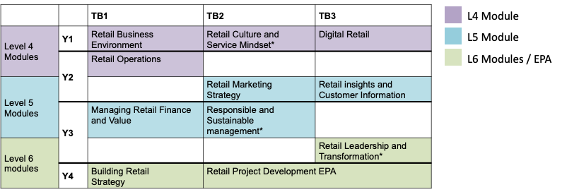
*Module includes Future Skills
Full details of each module is provided in module descriptors and learner module guides.
Figure 1.1 Proposed programme learner journey from induction to EPA.
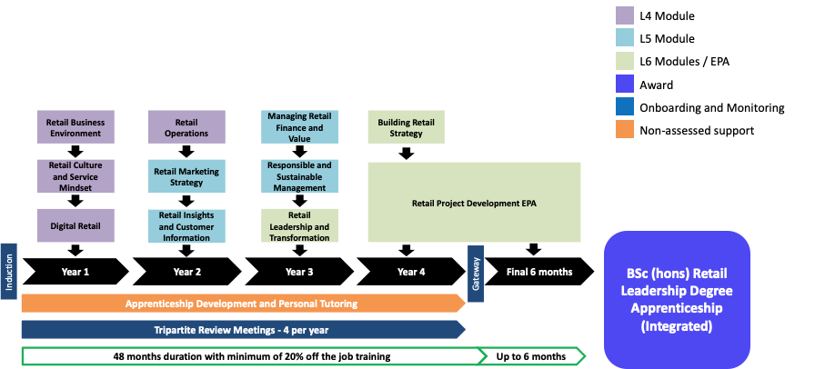

BSc (Hons) Retail Leadership Degree Apprenticeship

Level 4
BSc (Hons) Retail Leadership Degree Apprenticeship
Core modules | Module code | Credit  Value | Level | Teaching Block | Pre-requisites | Full Time | Part Time
Digital Retail | BB4411 | 30 | 4 | 3 | None | 1
Retail Business Environment | BB4410 | 30 | 4 | 1 | None | 1
Retail Culture and Service Mindset | BH4703 | 30 | 4 | 2 | None | 1
Retail Operations | BO4003 | 30 | 4 | 1 | None | 2

Exit Awards at Level 4

This course permits progression from level 4 to level 5 with 90 credits at level 4 or above. The outstanding 30 credits from level 4 can be trailed into level 5 and must be passed before progression to level 6.

Level 5
BSc (Hons) Retail Leadership Degree Apprenticeship
Core modules | Module code | Credit  Value | Level | Teaching Block | Pre-requisites | Full Time | Part Time
Managing Retail Finance and Value | BA5811 | 30 | 5 | 1 | None | 3
Responsible and Sustainable Management | BH5703 | 30 | 5 | 2 | None | 3
Retail Insights and Customer Information | BM5705 | 30 | 5 | 3 | None | 2
Retail Marketing Strategy | BM5706 | 30 | 5 | 2 | None | 2

Exit Awards at Level 5

This course permits progression from level 5 to level 6 with 90 credits at level 5 or above. The outstanding 30 credits from level 5 can be trailed into level 6 and must be passed before consideration for an award

Level 6
BSc (Hons) Retail Leadership Degree Apprenticeship
Core modules | Module code | Credit  Value | Level | Teaching Block | Pre-requisites | Full Time | Part Time
Building Retail Strategy | BM6718 | 30 | 6 | 1 | None | 4
End Point Assessment | BH6406 | 60 | 6 | TB3 |  | 4
Retail Leadership and Transformation | BH6405 | 30 | 6 | 3 | None | 3

Exit Awards at Level 6

The compulsory modules required for each learner to reach Gateway and for completion of the final module which is integrated into the EPA.

- Teaching, Learning and Assessment

Much of the learning and teaching is through project- and problem-based activities, wherever possible informed and or delivered by current practitioners as well as academics. This approach also allows co-construction with learners by encouraging and supporting them to grow from being “fed facts” to developing knowledge, understanding and critical skills through exploration of subjects that interest them.

The industry-informed approach to teaching is further underpinned by the approach to assessment, which is, wherever possible, industry relevant and authentic – further preparing our future retail leaders for the tasks and challenges they are likely to face in the workplace. In addition to those currently in practice, and practice-based staff providing learners with connections to industry and the “real world”, research-active staff expose learners to the latest research developments.

Due to the fast-paced and dynamic nature of retail businesses and the requirement for learners to work across different shift patterns, this programme will be delivered remotely adopting blended learning practices in a block teaching model. The standard states that 90 credits are to be covered during each year of the apprenticeship, across a 4 year period. A model of one 30 credit module per teaching block with three teaching blocks per year has been developed to deliver requirements of learners, employers, KU academic framework and the associated apprenticeship standard.

Each delivery period will be one week long and represent the 20% ‘off the job’ component of the apprenticeship. There will be two one-week delivery periods per 12 week teaching block, running in week 1 and week 7 respectively. There will be two pieces of assignment per module, with one due on the final day of week 6 and week 12 of each Teaching Block. Exceptions to this include the modules at L4, L5 and L6 in which the Future Skills programme will be delivered, with specific Learning Outcomes to be assessed summatively, adding a small ‘low stakes’ (20%) assessment. In addition to this there will be 3 pieces of assessment for the final 60 credit L6 module which is integrated with the EPA.

During each week-long delivery period, teaching and learning will be delivered remotely using a series of online pre-recorded lectures, on-line remote synchronous seminars and additional associated guided eLearning activities such as reading, case studies and self-test quizzes. Each module will have 20 pre-recorded lectures, split into smaller lecture vignettes of circa 15 minutes. This is intended to create a more bitesize downloadable format for learners to watch and rewatch at their convenience. Each day of every week-long deliver period will have a proposed timetable as shown in figure 1.2 below. Self-guided learning and seminar preparation can include watching the associated lecture plus other preparation for the seminar. Each seminar will be 2 hours long (including breaks) and has been designed to support high levels of engagement, active learning, and learner interaction. In keeping with this, no more than 4 hours of online teaching per day has been proposed for this programme, with a maximum of 30 learners per cohort. This allows for suitably sized breakout rooms during each seminar for learners to work in small groups on shared exercises to enhance peer learning.

Available asynchronously will be topic specific platforms which seminar tutors will monitor and respond to on a weekly basis. Here learners will be encouraged to ask questions, post comments, share experiences and interesting examples form their workplaces. In addition to this, there will specific assessment forums dedicated to learner questions with shared answers for all learners. Platforms such as Padlet are likely to be deployed for this purpose.

Figure 1.2
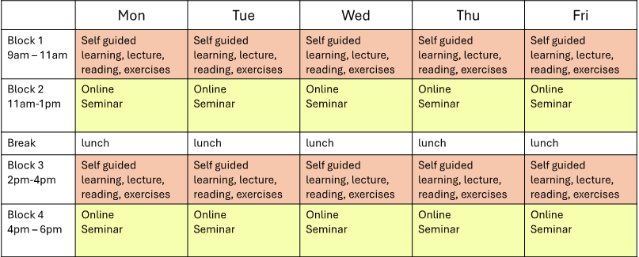
One exception to the online delivery plan, is the very L4 module which commences in week1 of TB1 Year 1. The first week-long delivery period of this module will be in person on campus at Kingston Business School. This will be an opportunity to run an induction to the programme for learners in the preceding week and enable learners to create a cohort identity and form peer relationships and communication channels to develop throughout the programme.

Assessment Strategy

Assessments typically require primary and secondary research to be undertaken, ensuring learners progressively develop critical thinking and information literacy skills at each level of the programme, but require presentation in a format that is industry-appropriate. Assessment methods include reports, portfolios, presentations, placemat presentations and project plans. The latest technology is used to enhance learning and collaborative working. The assessment strategy ensures that learners have explicit formative opportunities for practice and feedforward designed to help them achieve their full potential in final (summative) assessment.

Our rich and inclusive curriculum is continually reviewed in consultation with our learners, employers and industry to take account of new developments, seeking to keep the programme exciting and lively. A range of methods is used to actively engage learners, including problem solving and enquiry-based learning, industry research and peer-assisted learning. Formative assessment develops key aims during the progress of a module.

Assessment loads are standardised at each level and staged throughout the programme to ensure coherence and an even, manageable workload. Word counts (and equivalent) have been standardised across the academic levels as follows:
Level 4: 30 credits 3000 words or equivalent
Level 5: 30 credits 4000 words or equivalent
Level 6: 30 credits 5000 words or equivalent
The final 60 credit module at L6 is an exception to this as it is integrated with the EPA for which a 10000 word equivalent report is required by the apprenticeship standard
Where possible this programme will seek to deliver authentic assessment, aligning tasks set to reflect the retail business experience. This will provide opportunity for skills and knowledge to be built that will be valued and applicable in the workplace. Each module, subdivided into two 6-week periods, will set the assessment at the beginning of each period for submission at the end of the 6-week period.
Some examples of authentic assessment could include:
- An in-depth personal analysis and reflection on practice, identifying key areas for personal development as a future retail leader, with the creation of a dynamic Personal Development Plan that will be reviewed throughout the programme.
- Using a range of theory and models, review talent management processes in your own organisation and critically discuss how this can influence organisational performance. Identify areas for development and provide recommendations with guidance on how these can be implemented within the organisation.
- Using theoretical concepts of the strategic marketing process, respond directly to a real business challenge regarding (for example) external factors affecting the supply chain, making recommendations to the business on subsequent courses(s) of action to take,
- Apprentices will have the opportunity to use theoretical skills in the workplace and use experience and knowledge gained while working through the formative and summative assessment which is designed to ensure it can be contextualised in employment context. Regular 1:1 meetings with assigned skills coaches will support the acquisition of skills and knowledge in the workplace along with the quarterly tripartite reviews between each apprentice, provider and employer.

Consideration for the End Point Assessment (EPA)
A critical part of this programme is the EPA. Throughout the programme, apprentices will be made aware of the EPA and built into the delivery plan are mock activities and workshops that outline the requirements. There will also be provision for mock EPA activities to take place at the end of every year. Supporting evidence for the EPA in the form of a portfolio of evidence will be prepared throughout the apprenticeship, demonstrating the prescribed Knowledge, Skills and Behaviours. Throughout the programme the EPA will be discussed, and evidence collected as it is the professional award to which apprentices are working towards.
The final L6 module is integrated with the EPA and has been developed to take learners to Gateway with a robust and comprehensive project plan for onward completion during the EPA period.

- Support for Students and their Learning

Learners are supported by:
The Retail Leadership Apprenticeship (Integrated Degree) is a demanding course, both personally and academically. Learners are recruited from diverse academic backgrounds, some with relatively few academic qualifications. Strong emphasis is placed on supporting learners to achieve and, in order to promote successful outcomes, the course team has evolved structures to support learners’ wide-ranging needs. Academic skills development is introduced during the induction and embedded throughout the curriculum. This approach tailors support to the academic level of study to ensure learners develop their skills appropriately. The programme team and University provide a comprehensive matrix of roles and centralized services which are freely available to learners throughout their studies. These include:
- Module leader and teaching team: the module team are the primary source for academic support and assignment supervision. They coordinate tutorial support for the formative and summative submissions and ensure appropriate feedback and feed forward is provided. The module team will refer learners in need of additional support.
- Personal Tutor Scheme: Most learners on the programme are entering higher education for the first time and the combination of work, study and personal family commitments can be challenging. Every learner is allocated a named personal tutor who provides a constant presence and continuity of support throughout the programme, encouraging and motivating their tutees. Regular personal tutor group tutorials are timetabled to facilitate group support at key points. Learners have regular one-to-one meetings with their personal tutor to monitor their progression and development. Learners are also able to contact their personal tutor for further academic and pastoral support, as required. Where appropriate, the personal tutor will refer to the School’s dedicated specialist lecturer for academic support who can provide one-to-one assistance with academic skill development.
- ‘Buddy’ system: first-year learners are buddied with a second-year learner who is able to provide informal guidance and peer support from their own experience as a learner. This informal sharing of learning facilitates the growth of confidence in new learners and provides a network of support. It also assists second-year learners develop the supervision and supporting skills they require for professional practice. In year 1 of the programme, there will be no previous cohort from which to draw buddy support. Learners will be invited to form a small informal group of 2-3 peers during the induction period, with whom they will be encouraged to contact and make connection with during the year in an informal capacity. When the second cohort of learners join the programme in year 2, the buddy system as previously described will be actioned. Feedback from year 2 learners regarding their experience will be addressed and built into the buddy system.
- Academic Skills Centres: self-referral drop-in centres staffed by specialist academic support lecturers who provide small group and one to one support.
- Canvas: The University uses Canvas as its virtual learning environment which provides a versatile, interactive learning platform.
- IT support: Canvas has its own dedicated 24-hour support available to learners. Additional IT support can be accessed via ‘My Kingston’.
- Faculty Learner Achievement Officer: This is a non-academic role which provides pastoral support and advice. Learners can arrange a one-to-one meeting or attend drop-in appointments. The Learner Achievement Officer is able to sign-post learners to the wide range of services offered by the University. These include finance, accommodation, disability and dyslexia, health and wellbeing, counselling, faith and spirituality, Union of Kingston University Students.
- Access to world-class learning resource centres (LRC), online learning facilities and other learning support. LRC support staff offer academic skills development both within the LRC and also integrated into module delivery.
- Qualified disability advisor who gives guidance on reasonable adjustments and support for the learner and advises academic staff.
- Confidential counselling and pastoral support, including mental health support services.
- Comprehensive occupational health services if required, beyond the employing organisation’s own provision.
- Apprenticeship tripartite review meetings: These are held twice per year between apprentice learner, employer and university (workplace mentor) to review the learner’s progress and support needs. The frequency of the meetings is confirmed in the apprenticeship Commitment Statement which is issued at the start of the course and signed by the employer, the learner and university. It summarises the schedule, roles, responsibilities and funding to support the successful completion of the apprenticeship.

- Ensuring and Enhancing the Quality of the Course

The University has several methods for evaluating and improving the quality and standards of its provision. These include:
- External examiners
- Annual Monitoring and Enhancement
- Continuous Monitoring of courses through the Kingston Course Enhancement Programme (KCEP+)
- Learner evaluation including Module Evaluation Questionnaires (MEQs), level surveys and the National Student Survey (NSS)
- Moderation policies
- Feedback from employers

- External Reference Points

External reference points which have informed the design of the course. These could include:
- PSRB standards
- QAA Subject benchmarks
- Apprenticeship standards
- Other subject or industry standards

- Development of Course Learning Outcomes in Modules

This table maps where programme learning outcomes are summatively assessed across the core modules for this course. It provides an aid to academic staff in understanding how individual modules contribute to the course aims, a means to help students monitor their own learning, personal and professional development as the course progresses and a checklist for quality assurance purposes.

Module Code |  | Level 4 |  |  |  |  |  |  |  | Level 5 |  |  |  |  |  |  |  | Level 6
 |  | BB4410 |  | BH4703 |  | BO4003 |  | BB4411 |  | BA5811 |  | BH5703 |  | BM5705 |  | BM5706 |  | BM6718 |  | BH6405 |  | BH6406
Knowledge & Understanding | A1 | S |  |  |  | S |  | S |  | S |  | S |  |  |  |  |  |  |  | S
Knowledge & Understanding | A2 |  |  | S |  | S |  | S |  | S |  | S |  |  |  | S |  | S
Knowledge & Understanding | A3 | S |  |  |  |  |  |  |  | S |  |  |  |  |  | S |  |  |  | S
Knowledge & Understanding | A4 |  |  |  |  | S |  | S |  | S |  | S |  | S |  | S |  | S
Intellectual Skills | B1 | S |  |  |  |  |  | S |  | S |  |  |  | S |  | S |  | S
Intellectual Skills | B2 |  |  |  |  | S |  | S |  | S |  | S |  |  |  | S |  | S
Intellectual Skills | B3 | S |  | S |  | S |  |  |  |  |  |  |  | S |  |  |  |  |  | S
Intellectual Skills | B4 |  |  | S |  |  |  |  |  |  |  |  |  | S |  | S |  |  |  | S
Practical Skills | C1 |  |  |  |  | S |  | S |  |  |  |  |  |  |  | S |  | S
Practical Skills | C2 | S |  | S |  |  |  |  |  | S |  | S |  | S |  | S |  | S
Practical Skills | C3 |  |  | S |  | S |  |  |  |  |  | S |  |  |  |  |  |  |  | S
Practical Skills | C4 |  |  | S |  | S |  |  |  |  |  | S |  |  |  | S |  |  |  | S

Students will be provided with formative assessment opportunities throughout the course to practise and develop their proficiency in the range of assessment methods utilised.

Additional Information

