KINGSTON UNIVERSITY

Programme Specification

Title of Course: MSc Software Engineering.
Including the following pathways:
MSc Software Engineering with Management Studies
MSc Software Engineering (Web)
MSc Software Engineering (Web) with Management Studies

Date Specification Produced: 2012

Date Specification Last Revised: July 2018

V2

This Programme Specification is designed for prospective students, current students, academic staff and potential employers. It provides a concise summary of the main features of the programme and the intended learning outcomes that a typical student might reasonably be expected to achieve and demonstrate if he/she takes full advantage of the learning opportunities that are provided. More detailed information on the teaching, learning and assessment methods, learning outcomes and content of each module can be found in Student Handbooks and Module Descriptors.
SECTION 1: GENERAL INFORMATION
Title: | MSc Software Engineering  Including the following pathways:  MSc Software Engineering with Management Studies  MSc Software Engineering (Web)  MSc Software Engineering (Web) with Management Studies
Awarding Institution: | Kingston University
Teaching Institution: | Kingston University
Location: | Penrhyn Road
Programme Accredited by: | BCS The Chartered Institute for IT

SECTION2: THE PROGRAMME

- Programme Introduction

The construction of modern software projects with a multitude of quality requirements is a challenging and complex task particularly for large scale systems. Underestimating this complexity may result in project failures at worst or the delivery of poor quality products that are plagued with software defects at best. However, introducing academic and scientific rigor at every step of the software development life cycle (SDLC), be it ‘agile’ or ‘waterfall’, can tackle many of the complex problems faced in today’s software industries.
Thus, the common aim of all pathways within MSc in Software Engineering is to “develop high quality software systems cost effectively” – to ‘engineer’ rather than just ‘build’. The course equips the students with state of the arts techniques and tools necessary to conduct various stages of development in an explicit, structured fashion that is cost-effective and appropriate for the problem at hand. Starting with business processes and requirement engineering, through design, modelling, system architecture, and component based development, the course goes on to cover implementation and testing. Quality Assurance (QA) is at the core of Software Engineering, and one of the novel aspects of this course is that QA is considered as early as possible in the SDLC in order to reduce software defects leakage through the different SDLC stages, for example, requirement engineering covers not only requirements capture but also validating the correctness of the process. To achieve its aims the course covers a number of specialised topics ranging from traditional scientific formalism to modern paradigms such as Service Oriented Architecture and Cloud Computing.
In addition, the course has been developed in consultation with our industrial partners, which ensures that the students are equipped with skills required by the employers. It is also underpinned by the high quality research undertaken within the school particularly in software quality modeling and software architecture which can also equip students with the skills required to pursue higher research degrees such as PhD or research driven career. To ensure that the course content is relevant and up to date, the academic teaching on this career-enhancing course is complemented by visiting industry experts.
The School of Computing and Information Systems has a portfolio of degrees which are longstanding and well respected by industry. The MSc in Software Engineering has been accredited as fully meeting the educational requirement for BCS Chartered IT Professional and partially meeting the accreditation requirements for Chartered Engineer. Software Engineering (Web) is the new name for Web Development MSc, which is accredited by the BCS. “with Business” is the new name for “with Management”
The degree is offered in both full time and sandwich modes and has an excellent and proud history of employment both in large international companies and in UK based small and medium sized (SME) industries. The curriculum is backed by the research undertaken within the School of Computing and Information Systems. In addition it is informed by the School’s Industrial Advisory Panel.
The course is designed to cover the requirements of both the QAA Postgraduate Computing benchmarking statement and the professional body accreditation requirements. Students undertake practical project based exercises during the course, which culminates in an individual ‘capstone’ project at the end of the year. Many of the students’ projects will be for external clients.
We invest heavily in providing the latest equipment to support learning in the specialist computing laboratories of the School. These support a wide variety of the latest, industry standard software and tools for software engineering and development, delivered to any desktop. Students are encouraged to use their own preferred environments to support their current and future career aspirations. This includes virtual servers and virtual machines, a Forensic computing laboratory, and extensive Cisco networking equipment and development tools and a mix of wireless LAN technologies.
The School supports research activities that are of direct relevance to Software Engineering. Indeed, they underpin the optional modules, and specialist pathways included in the field. These activities are conducted within the Learning Technology Group (LTG), Digital Media for Health Group (DigHealth), the User experience research group (Ux) and the Component and Distributed Systems Research Group (CODIS). Research expertise and knowledge from projects undertaken by the LTG feed directly into software development modules in the form of interactive e-learning environments and virtualised development platforms and networks. CODIS research into software quality modelling and software architectures are reflected in the modules that are core to the Software Engineering Programme. Ux research in requirements of mobile applications, persuasive experiences and live traffic experiments feed directly into the User Experience Design (Systems) module. Mobile applications for Health developed by DigHealth provide sources for dissertation projects and case studies for the Mobile Computing option. Collaborative dissertation projects with the User Experience research group, and User Experience Design MSc students are also encouraged.

Pathways: Students taking the pure Software Engineering pathway consider in more depth the process that is key to the production of high quality systems – Quality Assurance – and the means of achieving efficienct development – software engineering tools.
By studying pure Software Engineering, students will acquire specialist understanding that adds value to software development teams and enables them to take on distinct, but widely needed responsibilities, such as ‘Software Engineer’, or ‘Lead Developer’. Team members that not only develop, but support and co-ordinate development with infrastructure, standards and procedures.
Web: Whilst pure Software Engineering focuses upon ‘making high quality software systems cost-effectively’, the Web pathway focuses upon the development of a certain kind of software system that is very widespread – software in which the major sub-systems are globally distributed , but then connected using a particular set of protocols (Internet protocols). A range of technologies, infrastructures and architectures have been devised to develop these sub-systems.
By studying Software Engineering (Web) students will acquire specialist engineering knowledge and skills in Web technologies, that add value to software development teams, and enable them to perform distinct, but widely needed roles, such as ‘web developer’ or ‘mobile developer‘.

With Management Studies: ICT empowers business processes and business change. Managers have the job of monitoring both the external environment in which their business operates, and the internal processes in order to make the necessary changes that will ensure that the organisation survives and thrives. Neither ICT specialists nor business managers can achieve an optimal result on their own; they must work cooperatively and collaboratively in order to succeed. However, business people and technologists often encounter communication difficulties. In short, they do not speak the same language.
By studying Software Engineering with Management Studies students will develop business skills that will enable them to work effectively with business managers to develop innovative and imaginative ways to exploit information and technology for business advantage. This is a key skill for employability, particularly as organisations in the public, private and voluntary sectors grapple with austerity.

Web with Management Studies: (see above)

- Aims of the Programme

The Aims of the Course are to:

- Equip students with the capability to exploit software engineering methods, tools and design skills which will enable them to design and develop applications for organisations in the 21st century.

- Enhance a student’s job performance and enable him/her to contribute effectively to the knowledge base of the employer.

- Give students the means to explore in detail the technical delivery architecture, systems integration, and consumer facing software systems.

In addition the PG Certificate will enable the student to:
- Maintain productive links with industry which provide sufficient background for an industrial/commercial dimension to the course.

- Undertake continuing professional development and updating for established IT professionals.

- Implant an enquiring, analytical and creative approach to both personal and professional activities that leads to the critical and responsible use of informed and independent judgement.

In addition the PG Diploma will enable the students to:

- Undertake a more effective role in software systems design and development.

- Gain a solid foundation in this specialist area, building on knowledge and skills gained from students individual backgrounds.

- Have an in-depth understanding of the new software development strategies and architectures appropriate to the design of Internet-oriented applications.

- Have an opportunity to study a subject area which is relevant to the field but also satisfies the individual's background and experience.

In addition the MSc will enable the students to:
- Have the ability to apply specialised knowledge and skills to the analysis and solution of novel problems in commerce and the industry.

In addition the aims of the course with business is to:
- Extend the student’s knowledge and skills into key areas of general management.
- Develop the skills to lead teams incorporating software engineering specialists, and systems architects, as well as other IT professionals.

- Intended Learning Outcomes

The programme provides opportunities for students to develop and demonstrate knowledge and understanding, skills and other attributes in the following areas. The programme outcomes are referenced to the QAA subject benchmark for Postgraduate Computing and the Framework for Higher Education Qualifications in England, Wales and Northern Ireland (2008), and relate to the typical student.

Programme Learning Outcomes

(see next page)
 | Knowledge and Understanding  On completion of the course students will have knowledge and understanding of: |  | Intellectual skills – able to:  On completion of the course students will be able to: |  |  | Subject Practical skills  On completion of the course students will be able to: |  | Transferable/key skills  On completion of the course students will be able to:
A1 | current developments in Software Engineering and their potential and limitations | B1 | Learn independently, think logically and critically and demonstrate a systematic approach to problem-analysis and to finding solutions. | C1 |  | Select and use effectively a wide range of methods, tools and techniques used in the design and development of software applications. | D1 | Self-Awareness  - Take responsibility for own learning and plan for and record own personal development  - Recognise own academic strengths and weaknesses, reflect on performance and progress and respond to feedback.  - Organise self effectively, agreeing and setting realistic targets, accessing support where appropriate and managing time to achieve targets.  - work effectively without supervision in unfamiliar contexts
A2 | the ethical, legal and professional issues in the development of software applications.. | B2 | Understand and define the business context that software applications can sit within, and across (e.g. a collaborative service scenario). | C2 |  | Specify software that meets the needs and aspiration of the users. This specification should include a conceptual data model for Web business applications, identifying entities and attributes, using a recognised notation. | D2 | Communication Skills  - Express ideas clearly and unambiguously in writing and the spoken word (including CV writing)  - Present, challenge and defend ideas effectively  - Actively listen to ideas of others in an unbiased way
A3 | software engineering principles and practical techniques required for the design and development of Web business applications. | B3 | Critically analyse and evaluate research in the chosen area. | C3 |  | Evaluate and select appropriate software engineering tools for a software development project, | D3 | Interpersonal Skills  - Work well with others in a group or team  - Work flexibly and respond to change  - Discuss and debate with others and make concessions to reach agreement  - Give, accept and respond to constructive feedback  - Show sensitivity and respect for diverse values and beliefs
A4 | the tools and technologies necessary for business application design and development. | B4 | Identify current issues in the area of software engineering. | C4 |  | Design optimal software architectures using appropriate methods and technologies, | D4 | Research and Information Literacy Skills  - Search for and select relevant sources of information  - Critically evaluate information and use it appropriately  - Apply the ethical and legal requirements in both the access and use of information  - Accurately cite and reference information sources  - Use software and IT technology as appropriate
 | Pure Software Engineering only  the processes necessary to assure the quality of complex systems, and to select, configure and utilise tools for cost effective development | B5 | Build upon the experience and responsibility gained as a result of the practical application of the skills acquired during the course to make a significant contribution as a computing or information systems professional within an organization | C5 |  | Pure Software Engineering only  Assess the quality of software and and optimise the process of its production . | D5 | Numeracy Skills  - Handle and understand number as required for context  - Interpret and apply data to inform judgements
 | Web only: Web services standards, such as XML, XSLT, SOAP, WSDL, RESTful web services, JSON, and associated standards bodies such as W3C, OASIS, WS-I & Liberty Alliance. Also identity management (Identity, authorization & authentication) and security requirements (encryption, security policy) | B6 | Specify and design systems architecture as appropriate and consider necessary trade-offs between centralised and distributed architectures | C6 |  | Web only: Incorporate Web browsers, VPN, firewalls, J2EE, .NET, XML, AJAX and other Internet technologies into business applications | D6 | Management & Leadership Skills  - Determine the scope of a task (or project)  - Identify resources needed to undertake the task (or project) and to schedule and mange the resources  - Evidence ability to successfully complete & evaluate a task (or project), revising the plan where necessary  - Motivate and direct others to enable an effective contribution from all participants
 | Management Studies Only  the tools and technologies necessary for business application design and development. |  |  |  |  | Management Stueis Only: Plan and control the development of a business in terms of financial, human resources and technology assets | D7 | Creativity & Problem Solving Skills  - View problems from arrange of perspectives to find solutions to problems  - Imagine, create and exploit ideas  Work with complex ideas and justify judgements made through effective use of evidence
Teaching/Learning Methods and Strategies

The range of learning and teaching methods and strategies include staff-student contact with a mixture of elearning as part of blended learning:
- Lectures  - Computer workshops/laboratories (staff or student (e.g. PAL) led)  - Group tutorials  - One-to-one tutorials  - Seminars |  |  |  |  | - Problem solving classes  - Directed reading (texts and work books: hard or e-copy)  - Directed programme of internet based lecture and tutorial videos  - Directed research projects  - Visits to outside organizations
Assessment Strategies

The assessment strategies employed are designed to include formative and summative assessments which test the learning outcomes of the course using the following mechanisms:
- Written examinations/tests  - Multiple choice tests  - Short answer tests  - Practical demonstrations  - Data interpretation exercises  - Design exercises  - Group presentations  - Individual presentations  - Essays |  |  |  |  | - Poster presentations  - Essays  - Individual reports  - Group reports  - Researched literature surveys  - Simulation exercises  - Case studies  - Research  - Computer-aided assessment
Teaching/Learning Methods and Strategies and Curriculum
Students make progressive use of more primary, research based sources of information, and by the end of their course will have developed the skills to analyze and appraise original sources, assemble data from various sources, solve problems and carry out an individual piece of work from planning, through analysis and the design, to a solution. This proof of concept will be documented and presented in the individual dissertation.
Throughout the degree emphasis is placed on developing team work skills, written and oral communication and presentation skills, data handling and analysis skills, a range of ICT skills and independent learning skills, which are supported by the School’s Academic Skills Centre daily drop-in sessions.

Assessment
Assessment is regarded as an integral part of the learning and teaching strategy, with ample opportunities given to students for formative assessment with rapid feedback that feeds forward into summative assessment.
Key skills developed during study of the course will be assessed within these various types of assessment (for example, the use of ICT is a normal expectation in the preparation of written work, reports etc; and data handling is inherent in many of the activities). The summative assessments are a mixture of a portfolio of coursework and end of module written assessments, usually unseen examinations. Each module carries a final grade, which is made up of the marks for course work and end of module assessments. The contribution of the individual assessments to the module total and the requirements to pass each module will be detailed in the module guides.
Formal expectation in the preparation of written work, reports etc; and data handling is inherent in many of the activities. Summative assessments are a mixture of a portfolio of coursework and end of module written assessments, usually unseen examinations. Each module carries a final grade, which is made up of the marks for coursework and end of module assessments. The contribution of the individual assessments to the module total and the requirements to pass each module will be detailed in the module guides.

- Entry Requirements

Applicants for the MSc and Postgraduate Diploma are normally required to have a good honours degree in IT, Computer Science, Software Engineering or the academic equivalent.

Exceptionally applicants may have no first degree but 5+ years working in a software design and development area. In this case, there must be strong evidence that the applicant has the motivation to complete the course and the ability to work at this level.

Both of these types of applicants will benefit from the advanced and specialised nature of the technical and business knowledge covered the course that is designed to build on the knowledge they already possess.

Overseas students are required to satisfy the Admissions Officer that they have reached an equivalent academic standard as those required for home students.

Language Requirements

IELTS – minimum 6.5 overall, including a minimum of 6.0 in writing, and a minimum of 5.5 in reading, listening and speaking
TOEFL IBT with overall score of 88, inc min score of 20/30 Writing, 20/30 Reading, 17/30 Listening and 20/30 Speaking

- Programme Structure

This course is part of the University’s Postgraduate Credit Framework (PCF). Courses in the PCF are made up of modules that are designated at level 7. Single taught modules in the courses are valued at 30 credits and the course contains a project that has 60 credits. The minimum requirement for a Postgraduate Certificate is 60 credits, for a Postgraduate Diploma 120 credits and a Masters Degree 180 credits.

The course offers the PG Certificate as an exit award only and is based on the student passing any coherent subset of the taught modules.

The awards available are detailed in section A and the requirements are outlined below. All students will be provided with the PCF regulations in the student handbook.

The Courses are offered as 1 year full-time, and normally 2-3 years part-time. The modules are offered as two, 1-week blocks several weeks apart. The full MSc course consists of an induction programme, 4 modules, and the project.

Full-time students will complete the programme of study and assessment in 52 weeks. The normal study pattern for part-time students is that they should complete 4 modules over a two to three year period and complete their project within the same period. Because of the structure of the course, part-time students may be able to commence the course at different times during the academic year after discussion with the Course Leader of relevant issues, including the need for specific preparatory study.

Normally, each module will include approximately 60 hours contact time, followed by directed learning resulting in a total of 300 hours of student effort. The project is the equivalent of two modules and requires 600 hours of student effort.

Planning meetings will take place at the beginning of each teaching block to ensure there is no assessment overloading or bunching.

The course design fully considers all student groups. Delivery in 1-week blocks separated by several week enables part-time students to study whilst also meeting their other commitments. Overseas students are also able to complete their degree within VISA limitations.

A January intake is accommodated by ensuring that two, technical core modules are delivered in the Spring semester, and that option modules and the Business in Practice module is delivered in the Autumn semester. This ensures that all students, including January starters taking ‘with Business’ pathways, can complete the individual project in the summer without disadvantage.

To address advanced ethics and professional issues, these issues are addressed within the context of technical core modules taken before the project is conducted, specifically, within Modelling Enterprise Architectures, and the Project Dissertation.

E1. Professional and Statutory Regulatory Bodies
BCS, the Chartered Institute for IT

E2. Work-based learning

The industrial placements team, aided by the Employability Co-ordinator, helps to prepare the students for interview and work, for example, with mock interview sessions, CV workshops, and industry speakers on employers needs.
Industry-hosted project dissertations are actively encouraged. It is the responsibility of individual students to source and secure such arrangements giving them more experience and employability skills after their MSc degree.

E3. Outline Programme Structure
The programme is made up of four modules each worth 30 credit points plus a project dissertation worth 60 credits. All students will be provided with the University regulations and specific additions that are sometimes required for accreditation by outside bodies (e.g. professional or statutory bodies that confer professional accreditation). Full details of each module will be provided in module descriptors and student module guides.

.
Level 7
Compulsory modules | Module code | Credit  Value | Level | %  Written exam | % practical exam | %  course-work | Teaching Block
Modelling Enterprise Architectures | CI7230 | 30 | 7 | 0 | 0 | 100 | 2
Software Architectures and Programming Models | CI7250 | 30 | 7 | 0 | 0 | 100 | 1
Project Dissertation | CI7000 | 60 | 7 | 0 | 0 | 100 | 1 and 2
Pure Soft Eng  Software Quality Engineering | CI7260 | 30 | 7 | 0 | 0 | 100 | 2
Web  Web Application and Infrastructure Development | CI7220 | 30 | 7 | 0 | 0 | 100 | 2
With Management Studies  Business in Practice | CI7600 | 30 | 7 | 50 | 0 | 50 | 1
Web with Management Studies  Web Application and Infrastructure Development | CI7220 | 30 | 7 | 0 | 0 | 100 | 2
Option modules |  |  |  |  |  |  |  | Pre-requisites
Pure Soft Eng and Web  Mobile Computing | CI7270 | 30 | 7 | 50 | 0 | 50 | 1
User Experience Design (Systems) | CI7700 | 30 | 7 | 0 | 0 | 0 | 1
Agile Project Development | CI7350 | 30 | 7 | 0 | 0 | 0 | 1
With Management Studies and Web with Management Studies
NONE
Level 7 requires the completion of the four 30 credit modules and the project dissertation. The complete list of option modules available will be determined annually and is subject to resourcing.

Students must take the core modules to the field, plus the core modules to the pathway. Some programmes have an option module from the selection above to make a programme of 180 credits in total.
- Principles of Teaching Learning and Assessment

The Course is designed to give students a balance of theoretical and practical experience.
The programme is designed according to the KU Curriculum Design Principles and it utilises a wide range of teaching and learning methods to enable all students to be actively engaged throughout the course. The learning, teaching and assessment strategies reflect the programme aims and learning outcomes, student background, potential employer requirements, and the need to develop a broad range of technical skills with the ability to apply them appropriately.
Formal lectures are used in order to give the students a good background understanding in the area and to develop the theoretical aspects. These are then often reinforced by practical sessions and/or industry specialists who contribute throughout the course in order to give informative insight into industry developments.
The practical workshops, open forums, newswires (e.g. CBDiForum, earthweb, ebiz) and group presentations are introduced into the modules to provide students with a detailed understanding of the approaches taken in industry. The students are often given an opportunity to work with a client organisation on their coursework thus enabling them to experience a real-life work environment and enhancing their employability.
The course ensures that the students are exposed to team working through group presentations, joint report writing, joint research and lab work. The students develop presentation and communication skills through these activities as well as practise analytical thinking, focused literature reviewing and academic essay writing, as part of their coursework portfolio. In this way, they also improve their research and evaluation skills.
The student is required to further explore and exploit the information given in the modules through guided self study.
Students will be given close guidance to select a project that is relevant to their background and specialisation. During the project, the student will be expected to apply the knowledge acquired during the course. Key skills in communication, presentation, literature search, problem analysis, project planning, report writing and solution justification are all part of the learning outcomes defined in this course.
Contact Time
The programme consists of modules in which the learning outcomes are achieved through a combination of scheduled tutor lead activities and practice. Scheduled contact time with students given within each module guide consists of lectures, tutorials, and practical sessions. Contact with staff often takes place in the context of giving feedback on assessed work but will not necessarily be scheduled. In addition to these there are daily drop-in sessions at the School’s Academic Skills Centre where support is provided on a one-to-one basis.

StudySpace
StudySpace, the university’s learning management system, is used extensively in all modules as a means of dissemination of lecture notes, worksheets, assignments, reference materials, links, videos and lecturer annotated slides. In this way it acts as a repository for learning materials to be used by the students for independent study and in addition in some modules, for formative and summative tests and surveys.
Assessment and Feedback
The use of a variety of assessment methods is adopted as an appropriate assessment strategy to ensure all aspects of learning outcomes are covered and achieved. In particular:
- A portfolio of coursework assignments is designed to develop analytical and practical skills in a student, while an
- An unseen exam is designed to develop skills required in problem solving situations, commonly found in practice.

The formative assessment is used to help students answer particular components of the assessment by giving them timely feedback on exercises specially designed to simulate the exam questions or elements of the coursework assignments. The feedback is provided in:
- A written form thus presenting an additional learning resource helping the student build the knowledge throughout the learning process and prepare for the summative assessment.
- The exercises may take various forms including:
  - small building projects,
  - essay writing or
  - analysing past exam questions

At the end of the course every student undertakes a project dissertation which is a significant activity that draws on and enhances the skills and knowledge developed throughout the programme. As such, the assessment places greater emphasis on ability to plan work, manage time effectively, and research background information, culminating in portfolio of written reports and an interview.
In the programme as a whole, the assessment components as outlined in the Section C, under the Teaching/Learning and Assessment Strategies heading are used in all of the modules.

Research Informed Teaching
The School has internationally recognised research groups that feed into and support student learning through its teaching programme. Research in Software Engineering is focused in the Component and Distributed Systems Research Group (CODIS). The group conducts research into software quality modelling and software architectures supporting distributed service oriented scientific and enterprise applications. The research targets diverse environments, ranging from Cloud Computing to dedicated scalable high performance clusters with a special focus on the management of system resources and distributed services. In addition the CODIS is developing generic software quality models and metrics that allow meeting not only users’ functional requirements but also their non-functional requirements in the form of Quality of Service (QoS). The group is also developing new solutions for the integrated management of data, information and knowledge using service oriented, component and distributed technologies. Moreover, aspects of usability as a software quality factor is conducted within the User Experience Research Group.
The User Experience Research Group is responding to, and creating, the challenges and opportunities posed by the evolution of the Internet, and the applications and services it unites. It is studying the actual use of web systems in context, using its own research vehicle website, traffic analysis tools, and remote usability testing. It is also exploring new techniques for analysing user requirements of multi-channel, multi-site, multi-phase interaction (User Journeys, and Branded Experiences). Case study evaluation reports and methodologies now feature in the Experience Design (Systems) module, along with emerging design frameworks (credibility and persuasion). This expertise feeds directly into the content of the course maintaining its state of the art currency.
The Learning Technology Group is conducting research in online learning and its influence on pedagogy, teaching and learning and assessment within the computing subject area. Artefacts from this research include NoobLab, designed to provide an immersive learning experience for computer programming. This provides students with an environment in which practical exercises can be delivered in a stimulating, engaging fashion, with real-time feedback provided to the student as they work and progress at their own pace. Other initiatives include WLab, a virtualised platform for delivering complete computer environments over the web for practical experimentation. These tools are developed within Kingston University and actively inform the teaching process within the constituent disciplines of computing. Opportunities exist for suitably skilled and motivated students to contribute to this research as part of their dissertation project. They are also invited to actively participate in research seminars and presentations. These skills enable students to distinguish and present appropriate evidentiary information in an argument, which are greatly valued by employers.
Other research groups have experience of developing software systems and applications related to their specialisation, and this provides relevant expertise for supervising, and suggesting dissertation projects. The Digital Media for HealthCare Group has developed, for example, systems for personalised healthcare, mobile applications, and quality of service management in 4G networks. The Digital Imaging Research Center has developed applications for querying databases of CCTV footage, and for controlling distributed networks of cameras.
Students are able to develop their research skills which form a fundamental part of the curriculum. These skills enable students to distinguish and present appropriate evidentiary information in an argument. These skills are greatly valued by employers. Moreover, staff also engage with research into teaching and learning in Higher Education which feeds through to support learning in lectures and other forms of student engagement during contact time.

- Support for Students and their Learning

Students are supported by a highly qualified team of academic staff that includes individuals in the following roles:
- A Course Director to help students understand the programme structure
- A Personal tutor to help and guide the student throughout the course
- A Module Leader for each module

Additional support is provided by the following specialist staff:
- Technical Support to advise students on IT and the use of software
- A designated Programme Administrator
- English language support for international students

Matters outside the academic arena are supported by:
- Student support facilities that provide advice on issues such as finance, regulations, legal matters, accommodation, international student support etc.
- Disability and dyslexia student support
- A substantial Study Skills Centre that provides academic skills support
- Careers and Employability Service
- The Students’ Union
- An induction week at the beginning of each new academic session
- Staff Student Consultative Committee
- StudySpace – a versatile on-line interactive learning management system available on the university’s intranet
Support for Academic Skills
There is a range of support available within the School, which includes but is not limited to:
Faculty-wide Student Support team
SEC Study Skills (S³)
Drop-in Programming Sessions (Java Aid, C++ Aid)
Drop-in Maths Aid sessions

SEC Study Skills (S³) is a one-to-one drop-in Study Skills session for students every weekday. Help is available on a range of academic skills from writing reports, note-taking, to exam revision, referencing, and mathematical skills.
The Student Support Team help students with any problem which has an effect on their studies. This can range from illness, problems writing an assignment, questions about academic regulations to serious confidential issues.
The students are introduced to all these mechanisms during induction sessions at the beginning of each new academic year. It is here that the students first encounter the university’s computer network, which includes their personal access to StudySpace and how to use it as a learning environment. They are also encouraged to make use of the substantial Study Skills Centre, an important resource that provides additional help across a range of academic skills.
Students are expected to be involved in the development of their programme. On an individual level through meetings with their course director and personal tutor at which they can discuss their academic progress, personal development and can seek advice on course and module choices in the light of their career aspirations. As a cohort, students can contribute to many aspects of programme evolution, for example by student representation on committees including Staff Student Consultative Committees as well as by their formal and informal feedback such as the mid-module and end-of-module reviews.

The Personal Tutoring Scheme

A Personal Tutor is allocated to each MSc student. Personal Tutors are recruited from the Course team – to ensure the students have the opportunity to benefit from various aspects of the profession that each individual academic brings. The personal tutors will meet with their students sufficiently frequently to maintain close communication and manage to provide information/advise on the matters relevant at the start of the course, address the progression and advise on the personal development leading to relevant career choices. Typically, there will be at least 2 individual meetings per semester, specifically at:
- The start of the semester/course to discuss the work patterns on the course and/or the choice of electives
- At the end of the teaching block to review the progress of individual students
There are also planned group meetings – one per semester – to discuss issues of common interest. At each of these meetings the students are encouraged to raise issues of their concern so that they can be resolved effectively and timely in due course.

Level 7 : Getting the most out of the Masters
- To help students to make the transition to Masters level study and understand how to use feedback on the postgraduate course
- To encourage students to be proactive in making links between their course and their professional and/or academic aspirations
- To explore students’ research aspirations
- To help students gain confidence in contributing to, and learning from, constructive peer review
- To encourage students to become part of a wider disciplinary and/or professional community
- To help students to prepare for the dynamics of supervision

- Ensuring and Enhancing the Quality of the Course
The University has several methods for evaluating and improving the quality and standards of its provision. These include:
- Periodic review undertaken at the subject level
- Periodic review for professional accreditation by the BCS: The Chartered Institute for IT
- Boards of study with student representation
- Annual monitoring and enhancement
- Student evaluation
- Moderation policies

- Employability Statement
Computing qualifications are amongst the most versatile and enable graduates to find employment in a wide spectrum of careers ranging from systems and business analysts, and software engineers, through to programmers and network specialists in a wide range of public and private sector industries. Recent graduates found employment with large organisations such as IBM, Hewlett Packard, Capgemini, JDA Software, Thomson Reuters, GlaxoSmithKline, Axa, BAA, British Telecom, Ernst & Young, Marks & Spencer, Waitrose, Virgin Media, NHS Institute for Innovation and Improvement as well as a host of smaller companies. Graduates also pursue careers in academia joining universities such as Kingston University’s PhD programmes in digital imaging, network security, and user experience.
Working on case studies designed to simulate the working environment, typically in teams, gives students experience of applying the theoretical concepts to practice in a professional manner. Furthermore, they have the opportunity to work with client organisations on real-life problems as part of their coursework assignments in modules, such as CI7150 Modelling Enterprise Architectures and/or their project dissertation. There is therefore an opportunity for a student to develop communication and interpersonal skills throughout the course. They learn about time management and the value of prioritising and planning by involvement in such projects and in the learning activities outlined in Section F above.
The MSc in Software Engineering is based on strong connections between theory and practice. It is designed to equip the students with the knowledge, both theoretical and practical, and the technical skills required for the development of today's software projects as well as meeting new emerging technological trends and demands.
During the course students are expected to attend lectures and seminars, many as part of their modules, which are delivered directly by industrial practitioners. In addition, they will have an opportunity to gain professional certification.
In summary on graduation, students should have the technical and project management skills that enable them to progress in their career. They will be equipped with the knowledge required to manage complex software development projects which is essential for positions in software houses, consultancies as well as major industries where advanced software engineering combined with rigorous scientific knowledge is in great demand.

BCS the Professional Chartered Institute for IT
As an accredited BCS degree course students are eligible to join as student members thereby providing them with another route in which to monitor current industry standards and needs. They are eligible for full membership on the successful completion of their degree and they can continue within the BCS to Chartered Information Technology Professional (CITP) status, providing proof of experience in a competitive job market. It partially meets the accreditation requirements for CEng.

Curriculum, Employability and Practical Skills
Employability is signposted in the curriculum where the emphasis is on applying knowledge, developing practical skills and applying them in mini-projects representing typical workplace issues. Aspects of employability and professional, legal, ethical etc are covered in the Modelling of Enterprise Architectures module. The project dissertation enabling the student to showcase their ability to manage and develop their work. The course has several modules to choose from to cater to a broad range of careers ranging from software houses to large financial instituations
Curriculum developments are discussed by the School’s Industrial Advisory Panel. The School has strong links with both industry and the professional body, the BCS the Chartered Institute for IT. It hosts a local BCS chapter and several members of the School are involved with the Institute at corporate level.

- Approved Variants from the Postgraduate Regulations
None

- Other sources of information that you may wish to consult
QAA Benchmark statement website: http://www.qaa.ac.uk/Publications/InformationAndGuidance/Pages/Subject-benchmark-statement-Computing.aspx
Professional or statutory body information: http://www.bcs.org/
Module guides
Guidance on Enterprise and Entrepreneurship (Draft)
http://www.qaa.ac.uk/Publications/InformationAndGuidance/Documents/EE_Draft_Guidance.pdf
Student handbook

Development of Programme Learning Outcomes in Modules
Using the Criteria tables from the BCS – Institute for IT

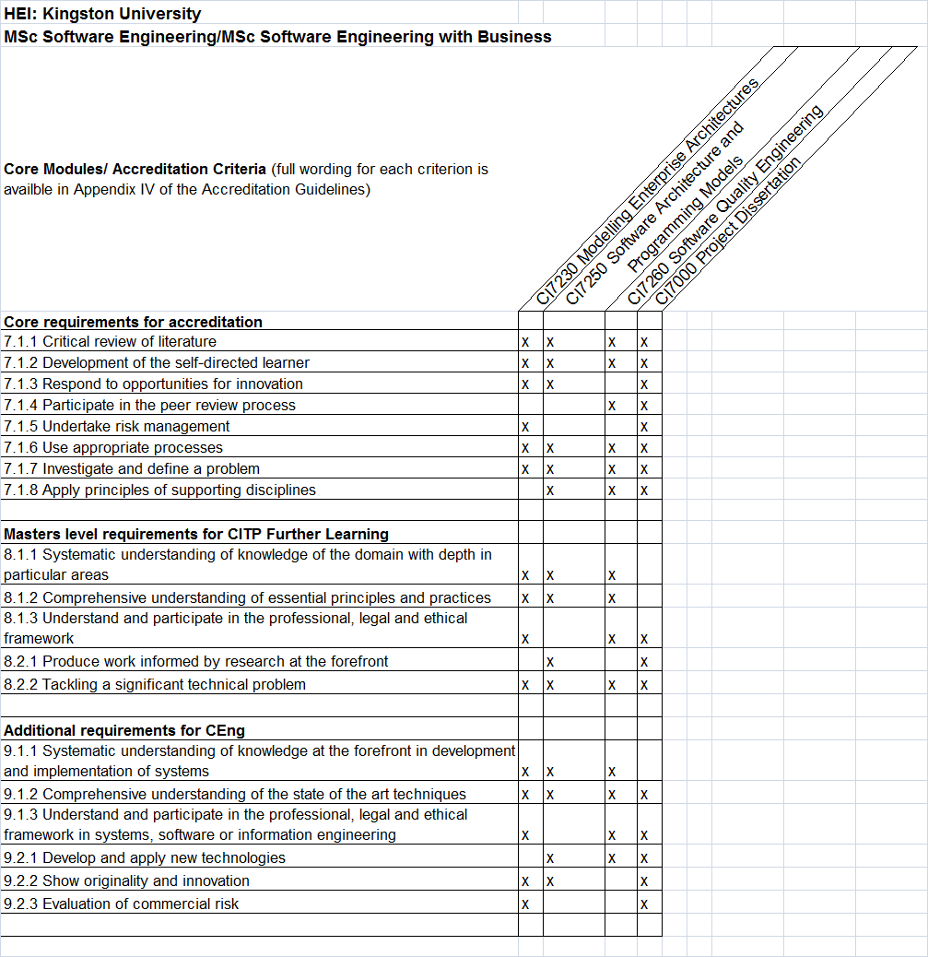

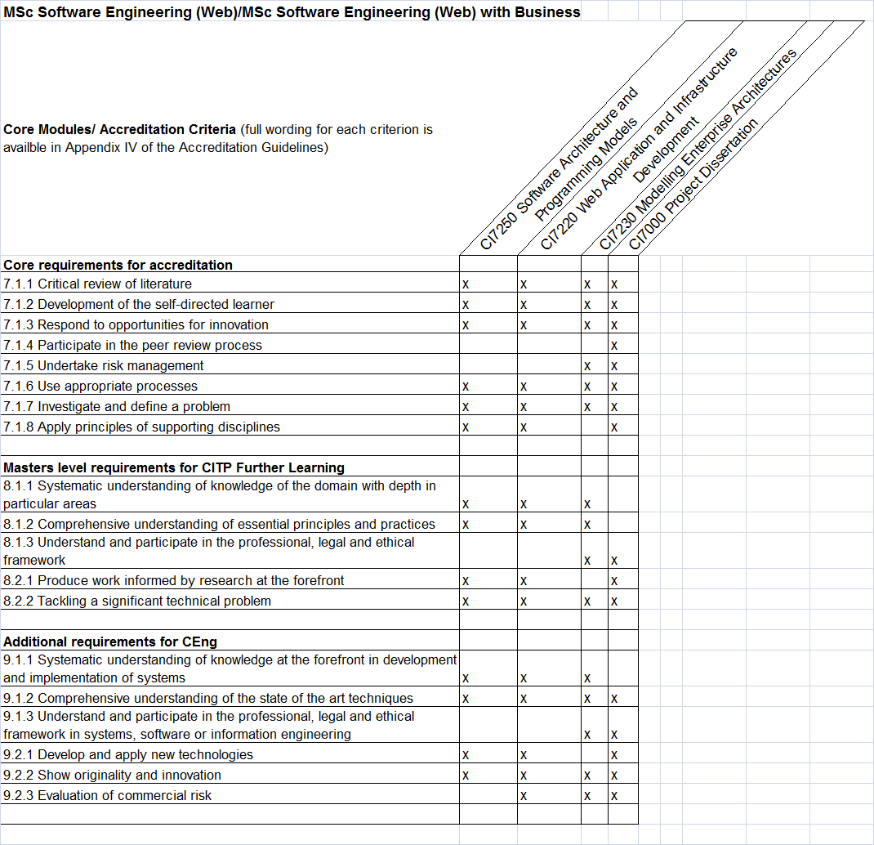
MSc Software Engineering
LEVEL 7 Core (30 credits) LEVEL 7 Recommended Options (30 credits)
Take One Of
CI7250
Software Architectures and Programming Models

CI7260
Software Quality Engineering

CI7230
Modelling Enterprise Architectures
CI7270
Mobile Computing
CI7700
User Experience Design (Systems)

CI7350
Agile Project Development

Level 7 Core (60 credits)
CI7000
Project Dissertation

MSc Software Engineering with Management Studies
LEVEL 7 Core (30 credits) LEVEL 7 Recommended Options (30 credits)
Take One Of

Not available in this programme
CI7250
Software Architectures and Programming Models

CI7600
Business in Practice

CI7260
Software Quality Engineering

CI7000
Project Dissertation

CI7230
Modelling Enterprise Architectures

Level 7 Core (60 credits)

MSc Software Engineering (Web)
LEVEL 7 Core (30 credits) LEVEL 7 Recommended Options (30 credits)
Take One Of
CI7700
User Experience Design (Systems)
CI7220
Web Application and Infrastructure Development

CI7250
Software Architectures and Programming Models

CI7270
Mobile Computing
CI7230
Modelling Enterprise Architectures

CI7350
Agile Project Development

Level 7 Core (60 credits)

CI7000
Project Dissertation

MSc Software Engineering (Web) with Management Studies
LEVEL 7 Core (30 credits) LEVEL 7 Recommended Options (30 credits)
Take One Of
CI7250
Software Architectures and Programming Models

CI7230
Modelling Enterprise Architectures
Not available in this programme

CI7220
Web Application and Infrastructure Development

CI7600
Business in Practice

Level 7 Core (60 credits)

CI7000
Project Dissertation

Technical Annex

Final Award(s): | MSc Software Engineering,  MSc Software Engineering with Manavement Studies,  MSc Software Engineering (Web),  MSc Software Engineering (Web) with Management Studies
Intermediate Award(s): | PG Diploma, PG Certificate
Minimum period of registration: | 1 year / 2 years (part time)
Maximum period of registration: | 2 years / 4 years (part time)
FHEQ Level for the Final Award: | 7
QAA Subject Benchmark: | Computing
Modes of Delivery: | Full-time, part-time
Language of Delivery: | English
Faculty: | Science, Engineering & Computing
School: | Computing & Information Systems
JACs code: | G600
Course Code:
Route Code:

